Chapter 1

Introduction ________________________________________________________________________

* 1. **PROJECT DETAILS**

**Organization :** Bhaskaracharya Institute for Space Application and

Geo-Informatics (**BISAG**), Govt. of Gujarat,

Gandhinagar.

**Project Title : “Water Resource Management System”**

**Front-End :** ASP.NET with C#

**Back-End :** PostgreSQL

**Software :** Visual Studio 2013, GeoServer

**Document tools :** Microsoft Office 2007, Umlet

**External Project Guide :** Mr. Vishal Patel (Project scientist, BISAG)

**Team Member :** 3

**Project Duration :** 13th December 2017 to 31st March 2018

* 1. **PROJECT PURPOSE:**

Purpose of creating this system is to make resource management fast as well as easy, which is easily manageable by administrator and to be used in current network efficiently.

Our WATER RESOURCE MANAGEMENT SYSTEM is intended to be used by Government of India Ministries/ Departments their organizations to publish datasets, documents and services collected by them for public use. It intends to increase transparency in the functioning of government and also open avenues for many more innovative uses of government data to give different perspective.

* 1. **PROJECT SCOPE:**

Three concepts are encompassed by the scope of the Water Resource Management System.

The first pertains to the replacement of paper-based information dataset using a digital format, the second relates to a complementary electronic strategy for the handling of user complains and the third surrounds the Visualization of Dataset in different user-friendly formats.

* 1. **PROJECT OBJECTIVE**

Water Resource Management System will provide an automate manner of activities right from managing the information of water resources to handling user Complains and Donations.

* System allows Admin to manage resources.
* System allows User to filter resources based on its type and state in which it is located.
* System allows User to download files uploaded by admin.
* System allows User to Register Complain if they find any issue with water.
* System allows User to donate funds for government welfare.

**1.5 TECHNOLOGY AND LITERATURE REVIEW**

**1.5.1 ASP.NET WITH C#**

ASP.NET is a mature web platform that provides all the services that you require to build enterprise-class server-based web applications using .NET on Windows.

ASP.NET offers three frameworks for creating web applications: Web Forms, ASP.NET MVC, and ASP.NET Web Pages. Each framework targets a different development style. The one you choose depends on a combination of your programming assets (knowledge, skills, and development experience), the type of application you're creating, and the development approach you're comfortable with.

We have used Web Forms for development of our Project. With ASP.NET Web Forms, you can build dynamic websites using a familiar drag-and-drop, event-driven model. A design surface and hundreds of controls and components let you rapidly build sophisticated, powerful UI-driven sites with data access.

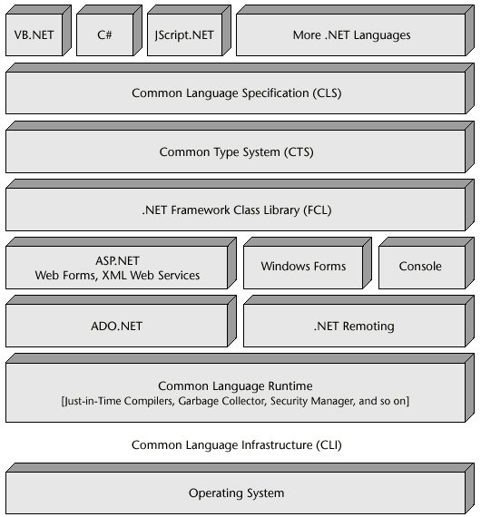

**1.5.2 VISUAL STUDIO 2013**

** Microsoft Visual Studio** is an [integrated development environment](https://en.wikipedia.org/wiki/Integrated_development_environment) (IDE) from [Microsoft](https://en.wikipedia.org/wiki/Microsoft). It is used to develop [computer programs](https://en.wikipedia.org/wiki/Computer_program), as well as [web sites](https://en.wikipedia.org/wiki/Web_site), [webapps](https://en.wikipedia.org/wiki/Web_app" \o "Web app), [web services](https://en.wikipedia.org/wiki/Web_service) and [mobile apps](https://en.wikipedia.org/wiki/Mobile_app).

Microsoft Visual Studio Community2013 is a very powerful development Environment, essentially a product with something for just about everyone. You can code apps and application in C++, C#, VB, F#,

HTML5, Python, JavaScript and more. Designers, editors, debuggers and profilers help to polish your work. There's web tooling for ASP.NET,Node.js, and JavaScript, and Apache Cordova and Unity tools mean you can target iOS and Android, as well as Windows.

**1.5.3 GEOSERVER [version 2.12.1]**

​GeoServer is a Java-based software server that allows users to view and edit geospatial data. Using open standards set forth by the Open Geospatial  Consortium (OGC), GeoServer allows for great flexibility in map creation and data  sharing. Geoserver is built based on Geotools, an open source Java GIS toolkit.

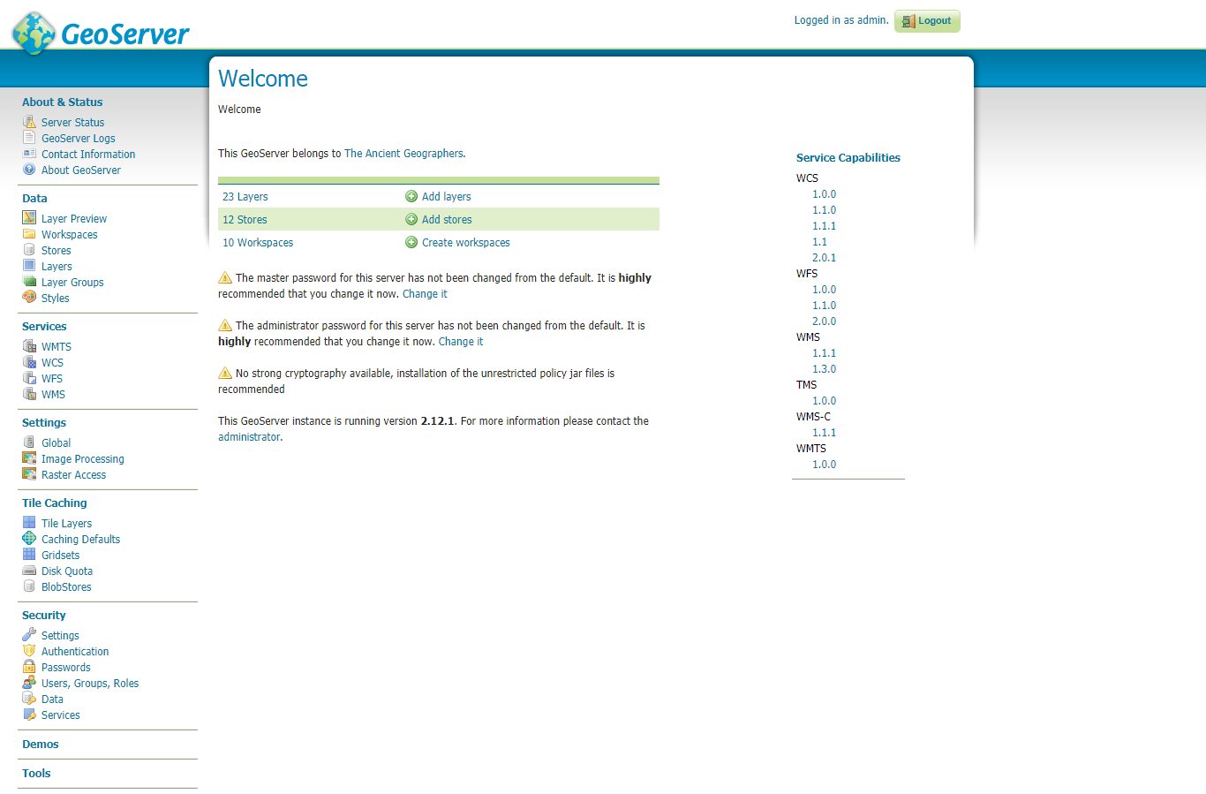

**1.5.4 OPENLAYER3 :**

OpenLayers is an open source JavaScript library for displaying map data in web

browsers as maps.



It provides an API for building rich web-based geographic Applications

similar to Google Maps and Bing Maps. OpenLayers makes it easy to put a dynamic map in any web page. It can display map tiles, vector data and markersloaded

from any source. OpenLayers has been developed to further the use of

geographic information of all kinds.

The shapefile format is simple, it can store the primitive geometric data types of points, lines, and polygons. Shapes (points/lines/polygons) together with data attributes can create infinitely many representations about geographic data. Representation provides the ability for powerful and accurate computations.

**1.5.5 POSTGRESQL/ POSTGIS:**

PostgreSQL, often simply Postgres, is an object-relational database management system (ORDBMS) with an emphasis on extensibility and standards compliance. As a database server, its primary functions are to store data securely and return that data in response to requests from other software applications.

Along with the above plugins/library the front end will be coded using HTML, CSS and Javascript while the back end will be coded using asp.net with C#.



Chapter 2

About the System ________________________________________________________________________

**2.1 MAIN MODULES OF THE SYSTEM:**

There are two main modules of the system as mention below:

* **Users**
* Can Get Information.
* Can Register Complaint.
* Can Donate Fund.
* Can Download Files.
* Can View News.
* **Admin**
* Can Manage Resources.
* Can Handle Complaints.
* Can Upload Files.
* Can View Donations.

**2.2 MODULE DESCRIPTION:**

Sub modules of the system are as below:

1. **Display Water Resources**

System gives facility to display water resources in three different formats On Map, in Gridview and by Charts. It provides dropdown list according to name of resource and name of state. After applying proper filters, it shows relevant data in selected format.

System gives facility to add new resources in database and load it onto a map through two approaches: By Providing Data and by Drawing through GUI. Also Resources can be deleted if it becomes obsolete.

1. **News Feed**

System gives facility for admin to add news and policies announced by government which everyone can view on home page.

1. **Dataset Files**

System provides facility for admin to add files and documents related to system which registered users can download.

1. **Complaint Handling**

System provides facility for registered users of registering complaints and can also view the status whether the complaint is viewed or not, while admin can handle the status of complaint. At the time when admin views the complain, SMS will be sent to the user as an acknowledgement.

1. **Donation**

System provides facility to registered users for donating money if they want, which admin can view, how much money user has donated and on which date. System will generate a donation receipt and User can download it.

**2.3 CONSTRAINTS:**

**2.3.1 USER INTERACE**

* User is required to have at least one mobile number.
* The user must register their details for login process to access all the functionalities except news feeds.

**2.3.2 HARDWARE INTERFACE**

* The hardware required for using this system is just personal computer with internet facility.

**2.3.3 SAFETY AND SECURITY CONSIDERATION**

* As we have payment option for donation, valid credentials are needed.
* Password is stored in MD5 encryption format for security purpose.

**2.3.4 DESIGN AND IMPLEMENTATION CONSTRAINTS**

* Since this system runs on internet, internet facility for system is needed.
* The system must be reliable enough to run crash and glitch free more or less indefinitely or facilitate error recovery strong enough such that glitches are never revealed to its end-users.

**2.4 ASSUMPTION AND DEPENDANCIES**

**2.4.1 ASSUMPTIONS**

* The data retrieved from the shape shows existing water resource.
* Admin have already registered and have valid authentication credentials.

**2.4.2 DEPENDANCIES**

* All the functions are accessible to User only after login except news feed.

**2.5 HARDWARE AND SOFTWARE REQUIREMENTS:**

**2.5.1 Hardware Requirements:**

* Laptop/Personal Computers with 1.8 GHz processor, 2GB RAM and 5GB Hard Disk.

**2.5.2 Software Requirements For Development :**

* Operating system: Windows
* Visual Studio 2013
* PostgreSQL
* GeoServer 2.12.1

**2.6 PROJECT PLANNING AND SCHEDULING:**

**2.6.1 Project Development Approach and Justification**

**INCREMENTAL MODEL**

The incremental approach attempts to combine the waterfall sequence with some of the advantages of prototyping. This approach is favored by many object-oriented practitioners.

It basically divides the overall project into a number of increments. Then it applies the waterfall model to each increment. The system is put into production when the first increment is delivered. As time passes additional increments are completed and added to the working system. This approach is favored by many object-oriented practitioners.

**Fig 2.1 Incremental Model**

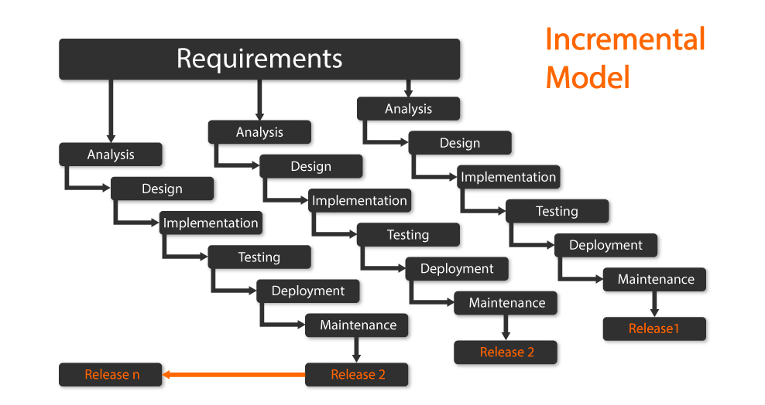

Our **Water Resource Management System** is based on **Incremental software process model.** The Incremental Model combines elements of the linear sequential model with the iterative philosophy of prototyping. The incremental model applies linear sequences in a staged fashion as calendar time progresses.

The incremental model is best suited in our project. As this incremental model diagram that each module are independent and don’t interact with each other. Whenever there is a new module needed to be adding such as at some time application will have to update then it is independently added without affecting any other module. In this type of project always some changes needed so as the time increase it must be changed so fulfill these types of requirement this model is best suited.

**Justification**

* If we have small team, we use this structure. Here we have three-person team.
* If customer or user not satisfied with core product then we provide 2nd incremental to them easily.
* Here we have all the requirements of system.

**2.6.2 Milestone & Deliverables**

Management needs information. As software is intangible, this information can only be provided as documents that describe the state of the software being developed without this information it is impossible to judge progress and schedules can not be updated. Milestone is an end point of the software process activity.

The project was mainly divided into two basic modules which are:

1. Admin Module
2. User Module

We have divided the software process into activities for the following milestone that should be achieved. At each milestone there should be formal output such as report that can be represented to the management.

* Milestone represents the end of the distinct, logical stage in the project.
* Milestone may be internal project results that are used by the project manager to check progress.

**Table 2.2 Milestones and Deliverables**

|  |  |
| --- | --- |
| **Software Process Activity** | **Milestone** |
| Project Plan | Project schedule |
| Requirement Collection | User requirements |
| Data flow analysis | System flow |
| Design   1. Database design 2. User Interface design | System Design Document |
| Implementation   1. Code for giving security 2. Code for reports | Access Rights  Reports |
| Testing | Setting validations and error messages |

**Schedule Representation**

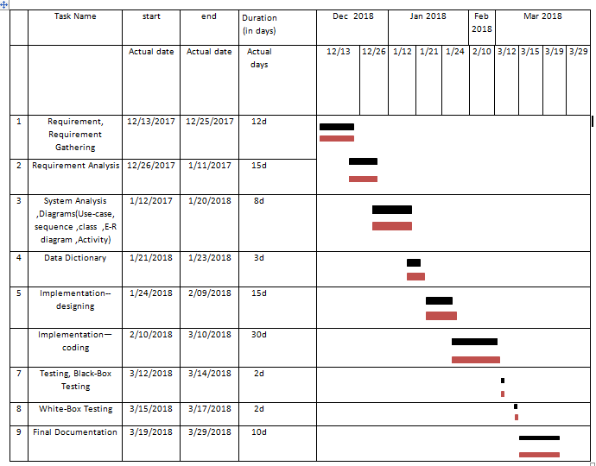

Chapter 3

System Analysis ________________________________________________________________________

## **3.1 FUNCTIONAL REQUIREMENTS**

Functional requirements define the fundamental actions that must take place in the software in accepting and processing the inputs and generating the outputs

## **3.1.1 Login**

**R1: System allows user to login.**

R1.1: System authenticates Admin and User based on Email-Id and Password.

Input: Email_id,Password

Processing: System matches the entries in the database. if match is found then set

auth_status to Admin or User, else print amessage and allow user to

change the password if registered.

Output :auth_status

R1.1.1: if auth_status is 1 then redirect to Admin domain.

Input: auth_status

Processing: System will be redirected to main page of admin.

Output: Admin_Homepage

R1.1.2: if auth_status is 0 then redirect to User domain.

Input: auth_status

Processing: System will be redirected to main page of user.

Output: user_Homepage

R1.1.3: if user has forgotton the Password,System gives the Password.

Input: Security_question, Answer, Email_id

Processing: System matches entered details with the entries in the

database. if match is found then provides Password which is

visible for 5 Seconds on screen.

Output: Password

R1.2: System offer users to create new account and register.

Input: FirstName, LastName, Email_id, Phone_no, Password,Security_question,

Answer, OTP

Processing: System provides interface through which users can enter details and

stores it in database after performing validations.

Output :status_successful_registration

**3.1.2 Security Question**

**R2: System allows Admin to view and manage Security Questions.**

Input: Sec_id

Processing: System fetches all the Security Questions from database

Output: Security_Questions

R2.1: System allows Admin to add questions for Forgot Password.

Input :Sec_id,Security_Question

Processing : System provides text field for inserting questions and

then store the details in database.

Output :Ques_add_Status

R2.2: System allows Admin to delete Security Questions.

Input: Sec_id

Processing: System removes question from database as per the

selection.

Output :del_Ques_flag

R2.3: System allows Admin to update Security Question

Input: item_id

Processing: System provides textbox to change the question. After

successful update, New details will be stored in the database.

Output :upd_Ques_flag

## **3.1.3 Display Water Resources**

## **R3: System allows Admin to manage resources**.

R3.1: System allows Admin to add resources.

R3.1.1: System allows Admin to add resource through UI.

Input: name, type, data_object, coordinates.

Processing: System provides textbox to insert data and marker to

draw on Map.

Output :resource_added

R3.1.2: System allows Admin to add resource by providing coordinates.

Input: name,type,data_object, coordinates

Processing: System provides textbox to insert data and Latitude

and Longitude.

Output :resource_added

R3.2: System allows Admin to delete resources.

Input: gid

Processing: System allows user to sort data by state or type and remove

the details from database on selection.

Output: del_Resource_flag

**R4: System allows User to filter resources based on its type and the state in which it**

**is located.**

Input: resources_bystate/resources_bytype

Processing: System allows user to select state or type in dropdown and fetch data

accordingly from database

Output: resources_detail

**R5: System allows Users to view chart based on its type and state.**

Input: type or st_name

Processing: System provides dropdown to select state or type, accordingly fetch

data from database and generate charts

Output: details_on_chart

**3.1.4 DataSet Files**

**R6: System allows Admin to upload file**

Input: did,filename

Processing: System allows admin to browse and upload a file.

Output: file_added_status

**R7: System allows User to view and download uploaded files.**

Input: datasetfiles_show

Processing: System allow users to select file, fetches its data from database

and download file

OutPut: File_downloaded_successfully

## **3.1.5 Complain Handling**

## **R8: System allows User to register complain if they find issue with waterresources.**

Input: uid.city_name,state_name,Message

Processing: System provides facility to select state & city from dropdown and

textarea for registering complain and store all details in database.

Output: Complain_status

**R9: System facilitates Admin with Handling Complain module**.

R9.1 System displays complain details to the Admin with complain count of same

city and City name.

Input: Complain_show

Processing: System fetches details of complains from database.

Output: Complain_details

R9.2: System allows Admin to view each Complain and give acknowledgement.

Input: complain_id

Processing: System gives facility to select complain and give

acknwledgement message to user on single click.

Output: Complain_status

**3.1.6 Donation**

**R10: System allows User to donate funds for government welfare.**

Input: payment_details

Processing: System takes Details and payment is processed via payumoney, on

successful payment System generates challan receipt which can be

downloaded in pdf format and stores donation details in database.

Output: Donation_Challan

**R11: System facilitates Admin to view donations.**

Input: view_donation

Processing: System fetches donation details from databas

Output: show_donation_List.

**3.2 NON-FUNCTIONAL REQUIREMENTS**

Nonfunctional requirements define the needs in terms of performance, logical database requirements, design constraints, standards compliance, reliability, availability, security, maintainability and portability.

## **3.2.1 Performance Requirements**

As Performance requirements define acceptable response time for system functionality,

* The load time for user interface screens shall take no longer than two seconds.
* The log in information shall be verified within five seconds.
* Queries shall return results within five seconds.
* The server shall be capable of supporting no less than 100 concurrent connections.

## **3.2.2 Safety Requirements**

* There shall be consistency in variable names within the system.
* The graphical user interface shall have a consistent look and feel.
* Passwords are stored in encrypted format in database.
* System must be reliable and have good mechanism of recovery for database failures.

## **3.2.3 Security Requirements**

The identified non-functional security requirements that directly relate to the entire project are:

System use recovery protocol for database as transaction is one of the major aspect. Also provide safe login for both User as well as Admin using network protocols.

**3.3 SYSTEM ARCHITECTURE DESIGN:**

**3.3.1 USE-CASE DIAGRAM**

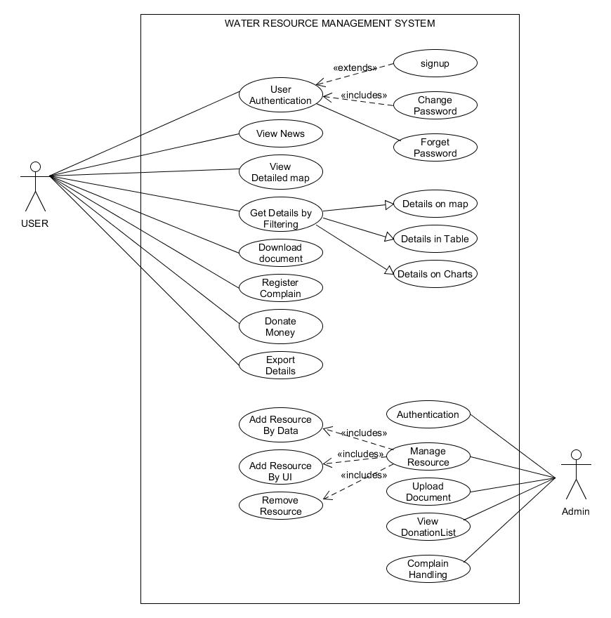

**Figure 3.3.1**

**3.3.2 CLASS DIAGRAM**

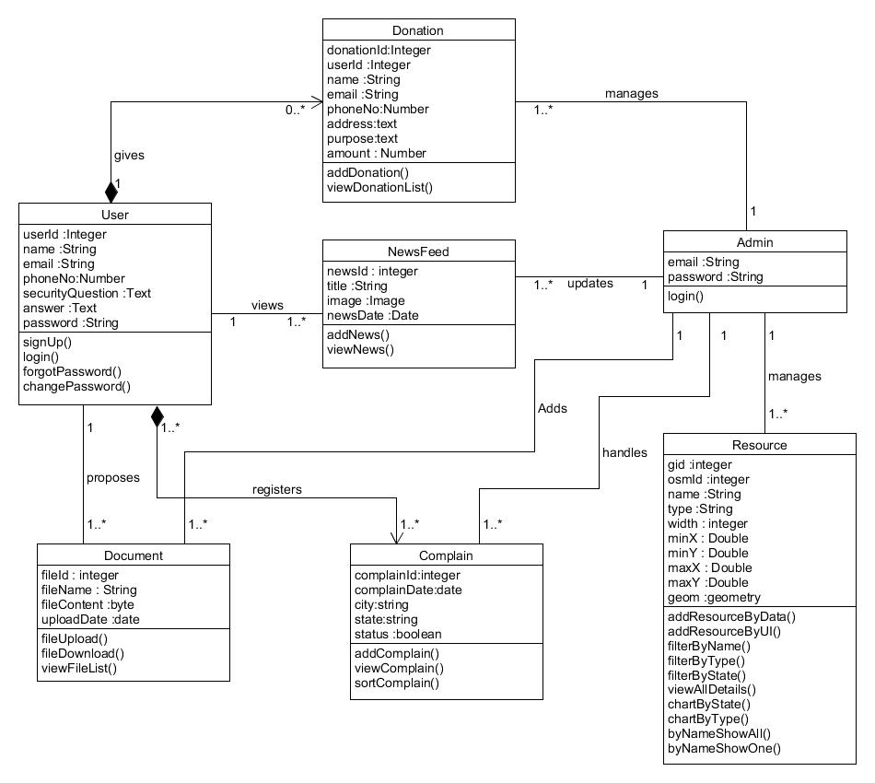

**Figure 3.3.2**

**3.3.3 ACTIVITY DIAGRAM**

* **Activity diagram for Showing Resource based on state/type**

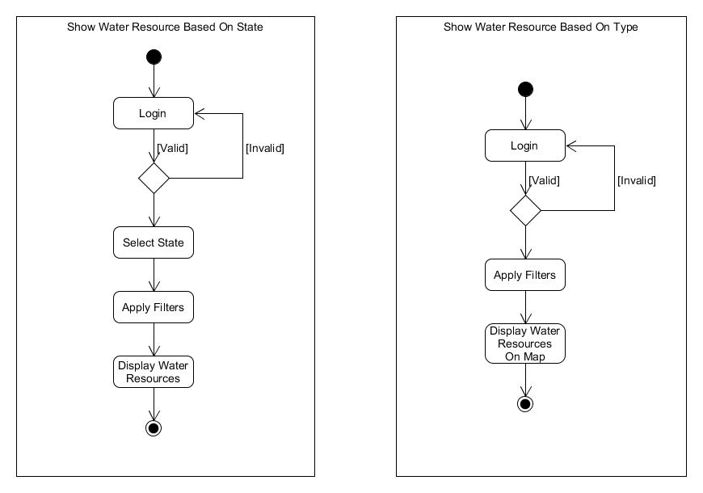

**Figure 3.3.3(a)**

* **Activity diagram for file Download and Upload**

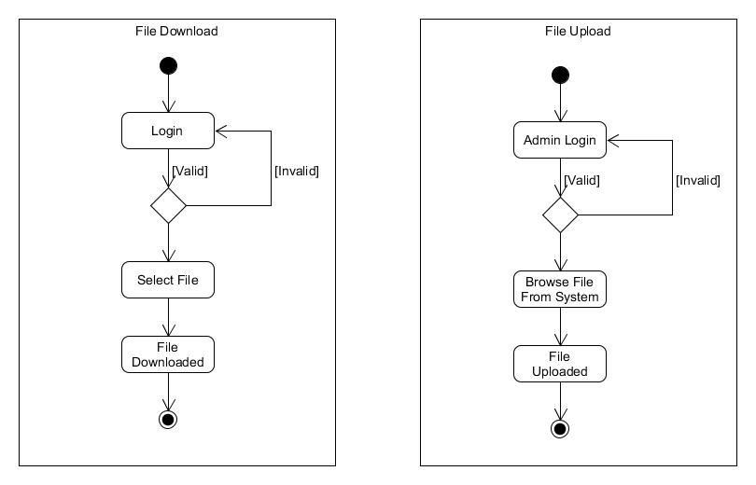

**Figure 3.3.3(b)**

* **Activity diagram for delete Resource**

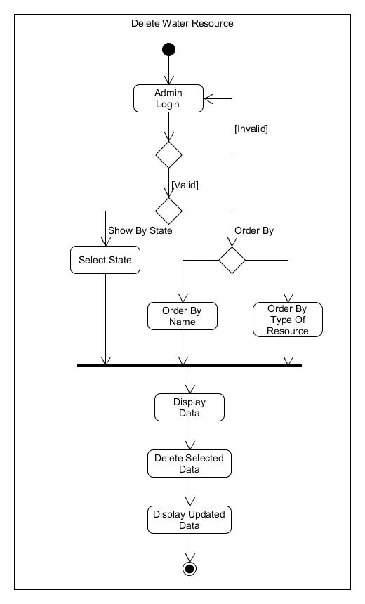

**Figure 3.3.3(c)**

* **Activity Diagram for Complaint Box**

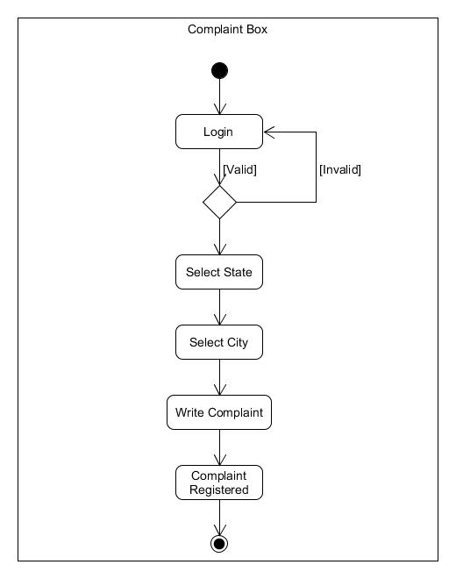

**Figure 3.3.4(d)**

* **Activity Diagram for Forgot Password**

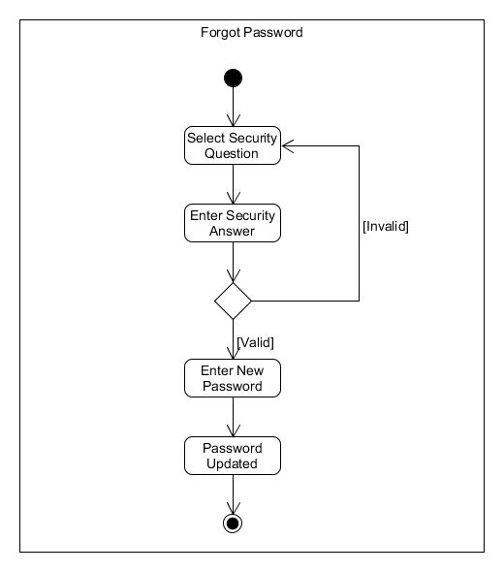

**Figure 3.3.3(e)**

**3.3.4 SEQUENCE DIAGRAM**

* **Sequence Diagram for Show by Type**

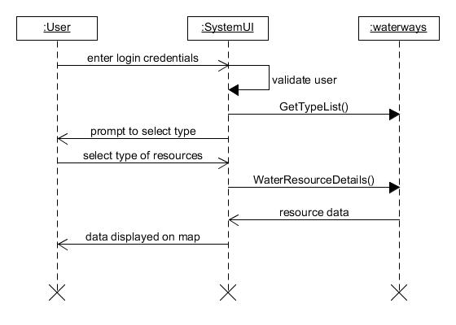**Figure 3.3.4(a)**

* **Sequence Diagram for Show by State**

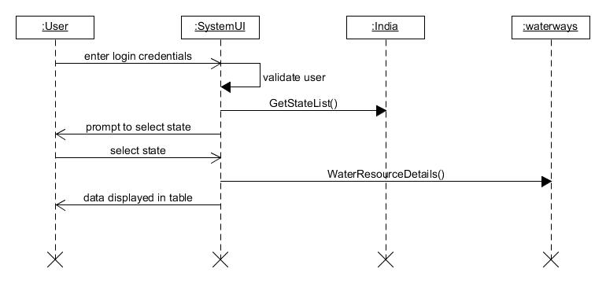

**Figure 3.3.4(b)**

* **Sequence Diagram for Delete Resource**

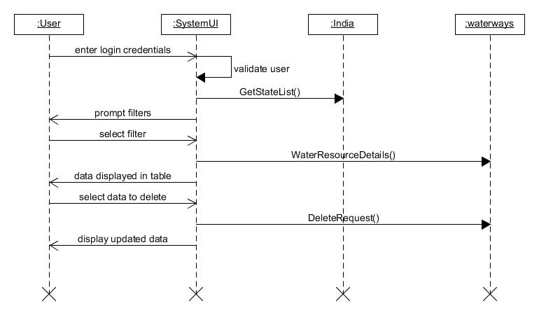

**Figure 3.3.4(c)**

* **Sequence Diagram for Forgot Password**

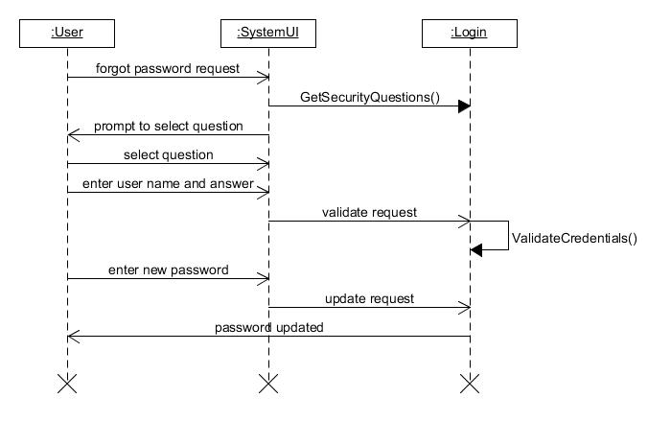

**Figure 3.3.4(d)**

* **Sequence Diagram for Complaint Box**

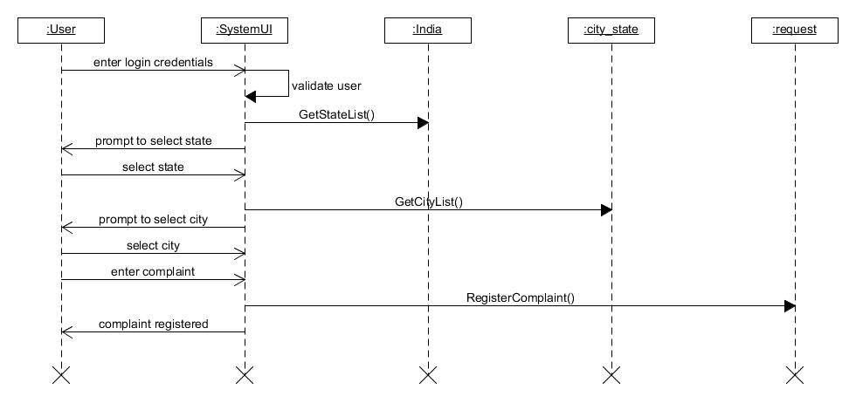

**Figure 3.3.4(e)**

**3.3.5 ER DIAGRAM**

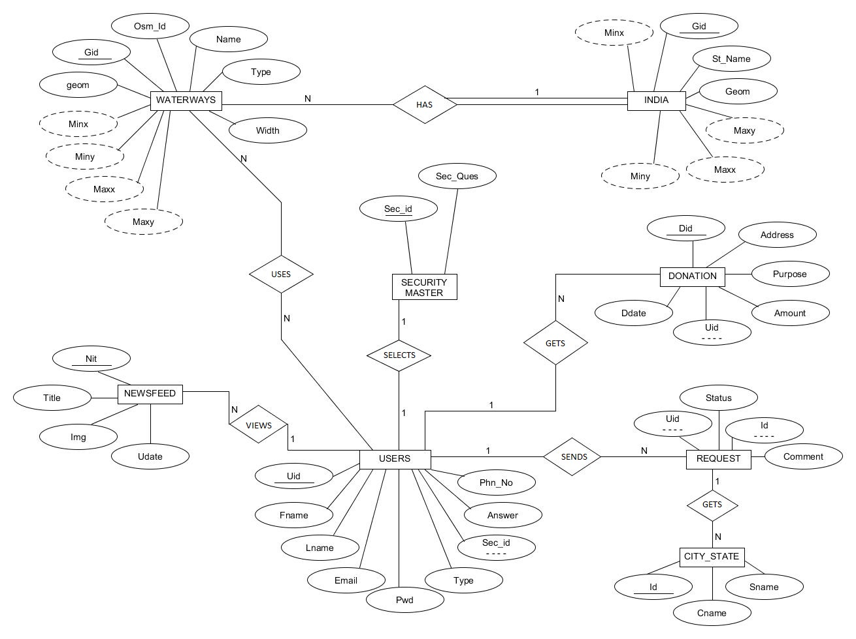

**Figure 3.3.5**

**3.3.6 DEPLOYMENT DIAGRAM**

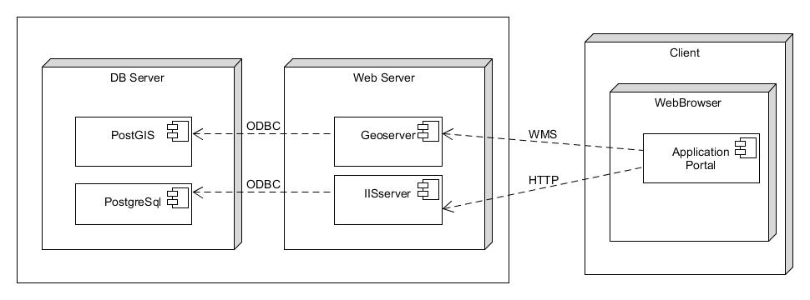

**Figure 3.3.6**

Chapter 4

System Design ________________________________________________________________________

.

**4.1 DATA DICTIONARY**

Data dictionary is a set of database tables used to store information about a database's definition. The dictionary contains information about database objects such as tables, indexes, columns, data types, and views.

1. Table Name : Users

Table Description: defines the details of Users who are registered.

Primary Key: id

Foreign Key: sec_id

**Table 4.1.1(a) Users**

|  |  |  |
| --- | --- | --- |
| Column Name | Type | Constraints |
| **Uid** | Int | Primary Key |
| Fname | Text | Not Null |
| Lname | Text | Not Null |
| Email | Text | Not Null |
| Phn | Number(10) | Not Null |
| Type | Text | Not Null |
| Pwd | Text | Not Null |
| Sec_id | Int | Foreign Key |
| Answer | Text | Not Null |

1. Table Name : India

Table Description: Contains the information of state of India.

Primary Key:gid

Foreign Key:

**Table 4.1.1(b) India**

|  |  |  |
| --- | --- | --- |
| Column Name | Type | Constraints |
| **Gid** | Int | Primary Key |
| st_name | Text | Not Null |
| Geom | Geometry | Not Null |
| Minx | Double | Not Null |
| Maxx | Double | Not Null |
| Miny | Double | Not Null |
| Maxy | Double | Not Null |

1. Table Name : Waterways

Table Description: Contains the information of different water resources.

Primary Key: gid

Foreign Key:

**Table 4.1.1(c) Waterways**

|  |  |  |
| --- | --- | --- |
| Column Name | Type | Constraints |
| **Gid** | Int | Primary Key |
| osm_id | Character(11) | Unique |
| Name | Character(48) | Not Null |
| Type | Character(16) | Not Null |
| Width | SmallInt |  |
| Geom | Geometry | Not Null |
| Minx | Double | Not Null |
| Maxx | Double | Not Null |
| miny | Double | Not Null |
| maxy | Double | Not Null |

1. Table Name : Newsfeed

Table Description: Defines the details of news

Primary Key :nid

Foreign Key:

**Table 4.1.1(d) Newsfeed**

|  |  |  |
| --- | --- | --- |
| Column Name | Type | Constraints |
| **nid** | Int | Primary Key |
| title | Text | Not Null |
| img | Byte | Not Null |
| udate | Date | Not Null |

1. Table Name :Security_Master

Table Description: Contains Secutiry Questions with unique id.

Primary Key :Sec_id

Foreign Key:

**Table 4.1.1(e) Security_Master**

|  |  |  |
| --- | --- | --- |
| Column Name | Type | Constraints |
| **Sec_id** | Int | Primary Key |
| Sec_Ques | Text | Not Null |

1. Table Name :City_State

Table Description: Contains Details of Cities in state.

Primary Key :id

Foreign Key:

**Table 4.1.1(f) City_State**

|  |  |  |
| --- | --- | --- |
| Column Name | Type | Constraints |
| **Id** | Int | Primary Key |
| Cname | Text | Not Null |
| Sname | Text | Not Null |

1. Table Name : Request

Table Description: Defines the information of registered Complains

Primary Key :

Foreign Key: id,Uid

**Table 4.1.1(g) Request**

|  |  |  |
| --- | --- | --- |
| Column Name | Type | Constraints |
| Id | Int | Foreign Key |
| Uid | Int | Foreign Key |
| Comment | Text | Not Null |
| Status | Boolean | Not Null |

1. Table Name : Donation

Table Description: Contains Details of donation done by user.

Primary Key :Did

Foreign Key: Uid

**Table 4.1.1(h) Donation**

|  |  |  |
| --- | --- | --- |
| Column Name | Type | Constraints |
| Did | Int | Primary Key |
| Uid | Int | Foreign Key |
| Address | Text | Not Null |
| Purpose | Boolean | Not Null |
| Amount | Number(10) | Not Null |
| Ddate | date | Not Null |

Chapter 5

Implementation ________________________________________________________________________

**5.1 SNAPSHOTS**

* **Home Page**

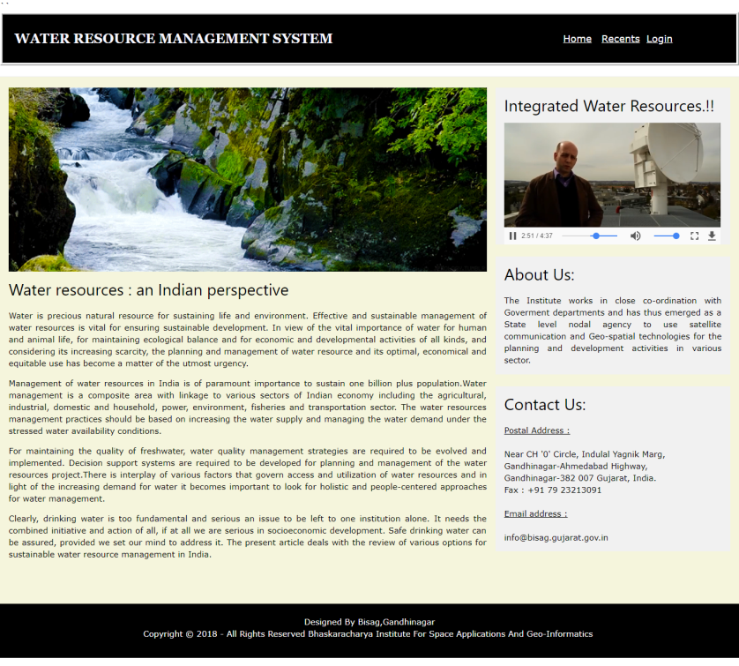

**Figure 5.1(1)**

* **News Feeds**

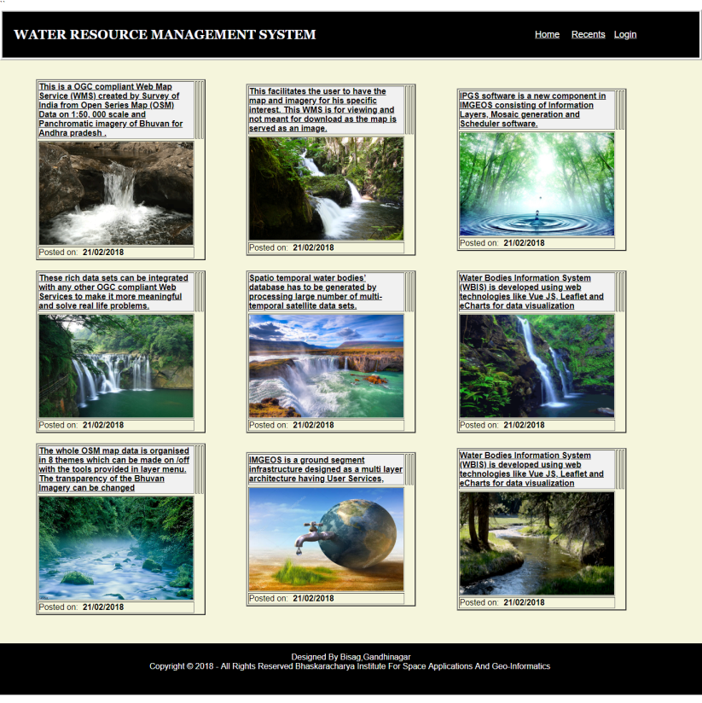

**Figure 5.1(2)**

* **Login Page**

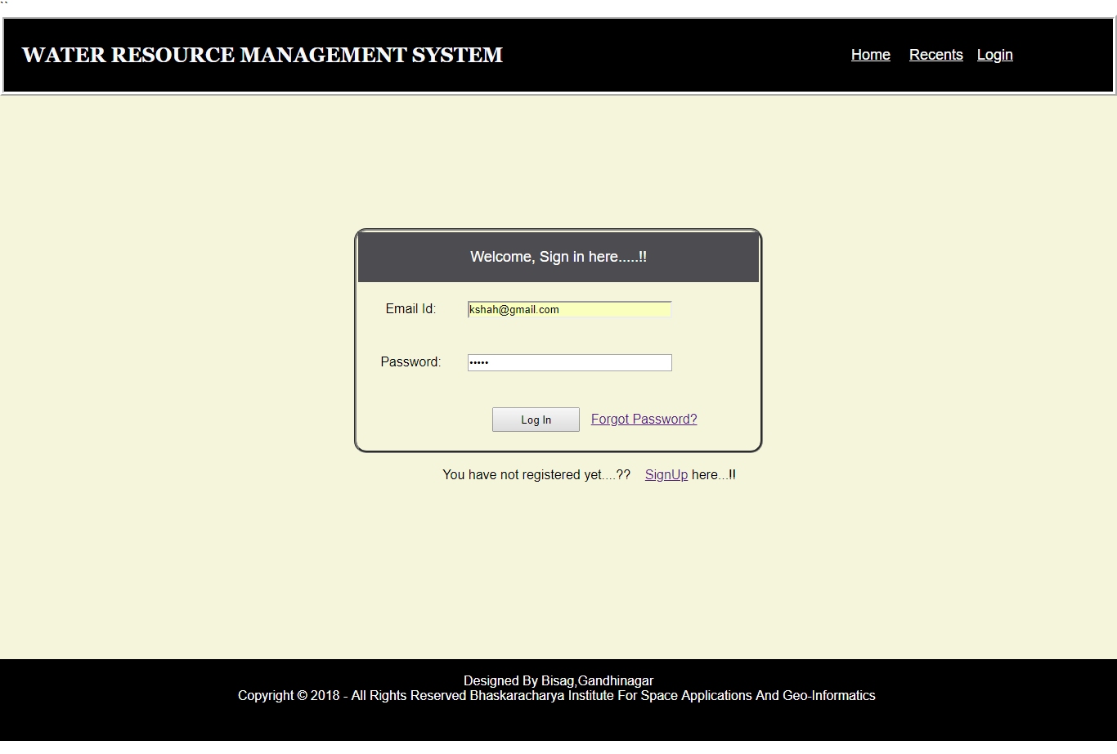

**Figure 5.1(3)**

* **Forgot Password**

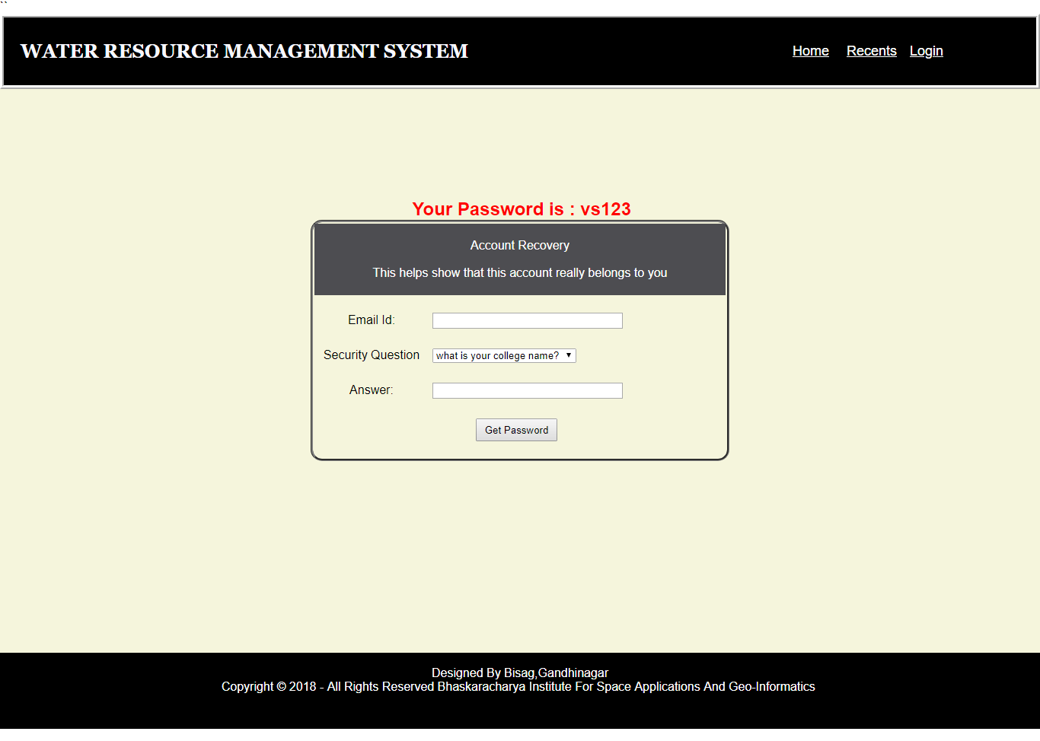

**Figure 5.1(4)**

* **Registration Page**

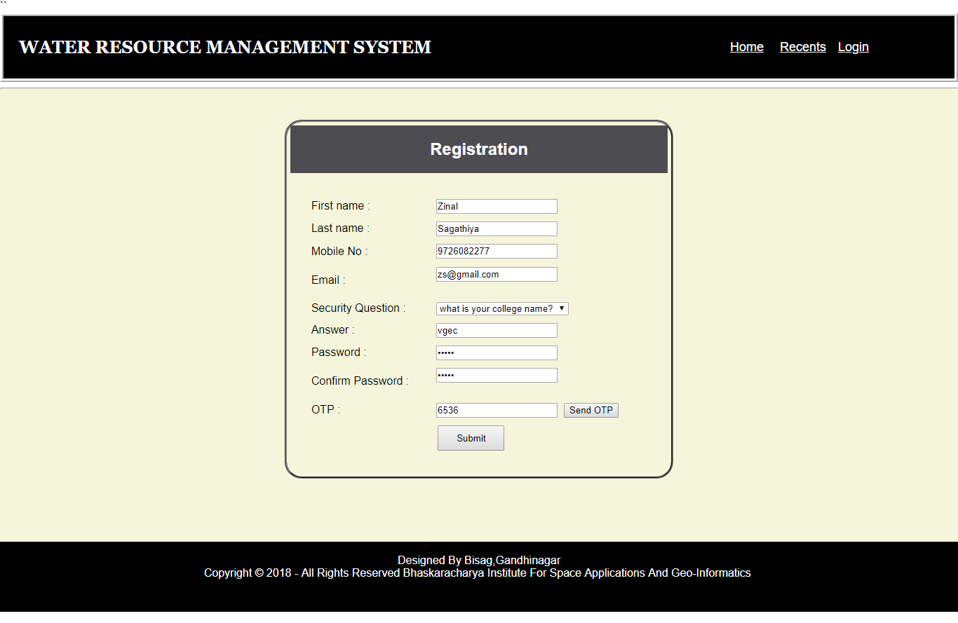

**Figure 5.1(5)**

* **OTP Message**

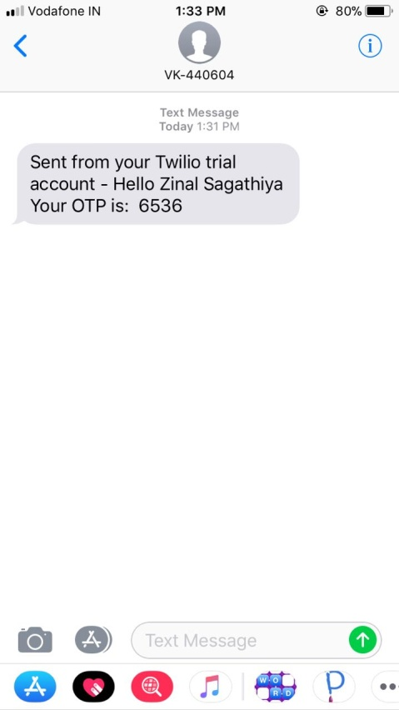

**Figure 5.1(6)**

* **User Home Page**

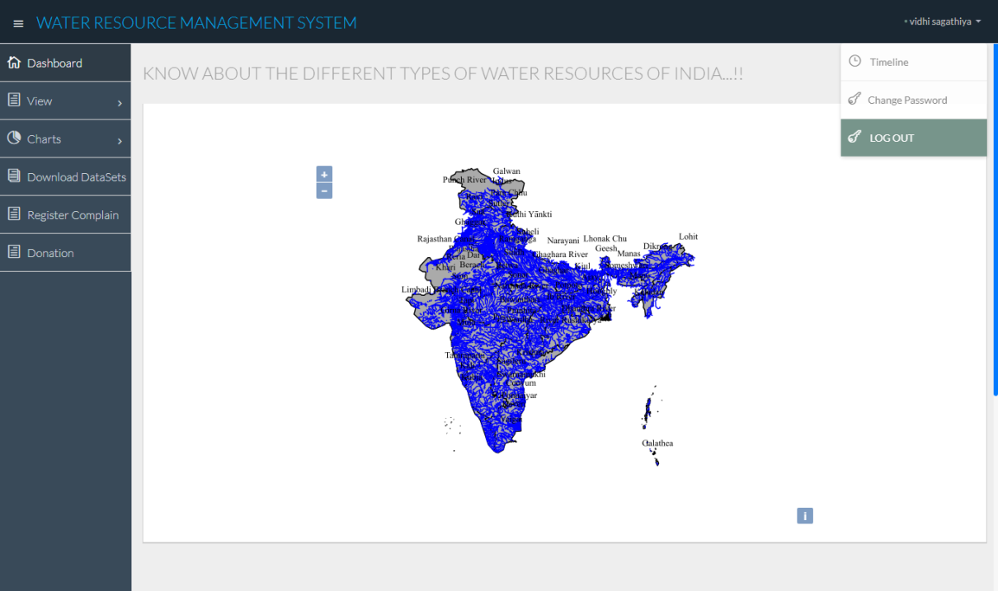

**Figure 5.1(7)**

* **View By Type**: User selects a particular type of resource from the dropdown list.

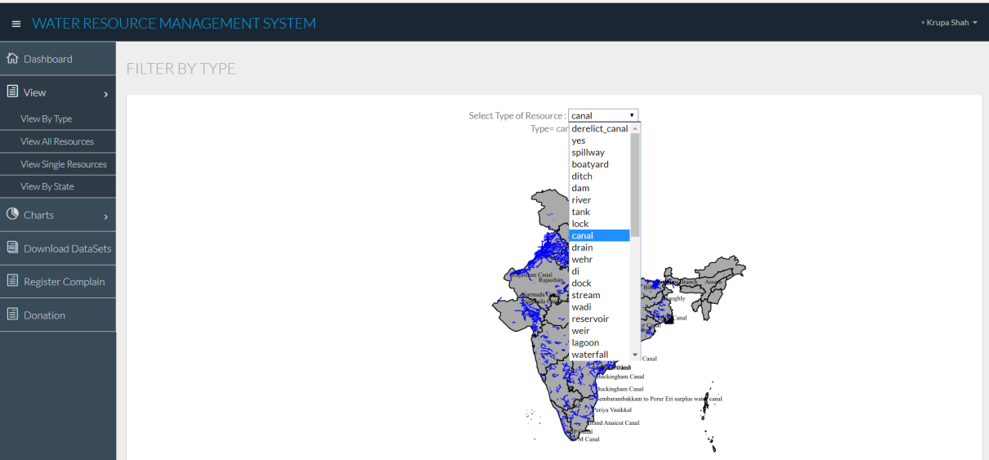

**Figure 5.1(8)**

Output of Figure 5.1(8):Shows the output of selected type

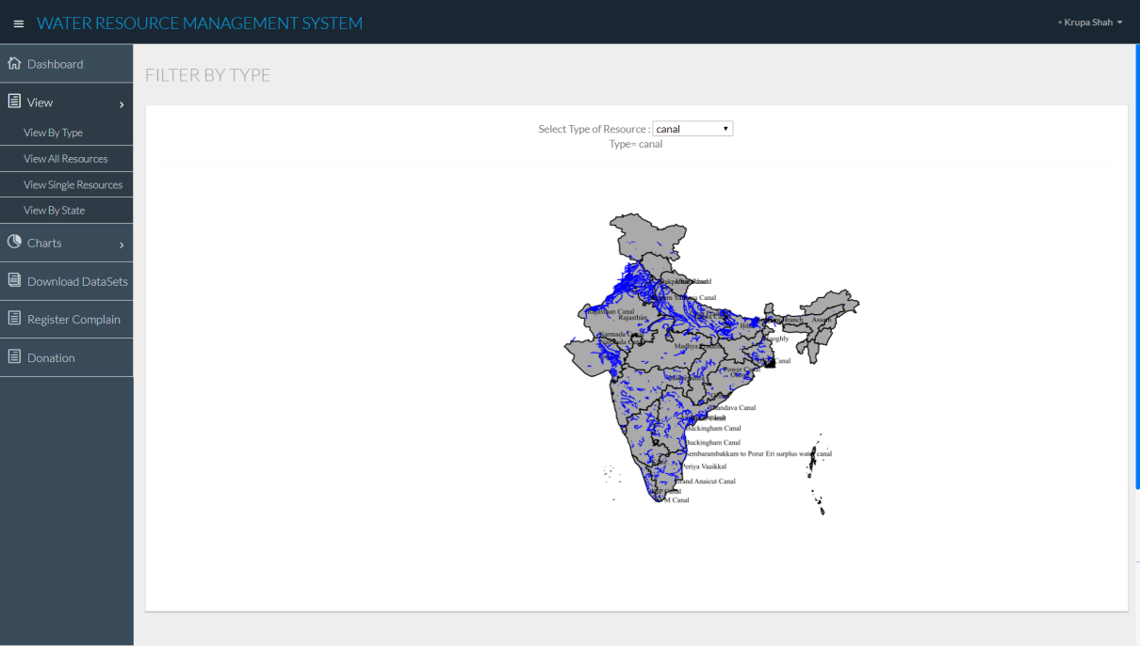

**Figure 5.1(9)**

* **View All Resource:** User selects a particular type of resource from the dropdown list.

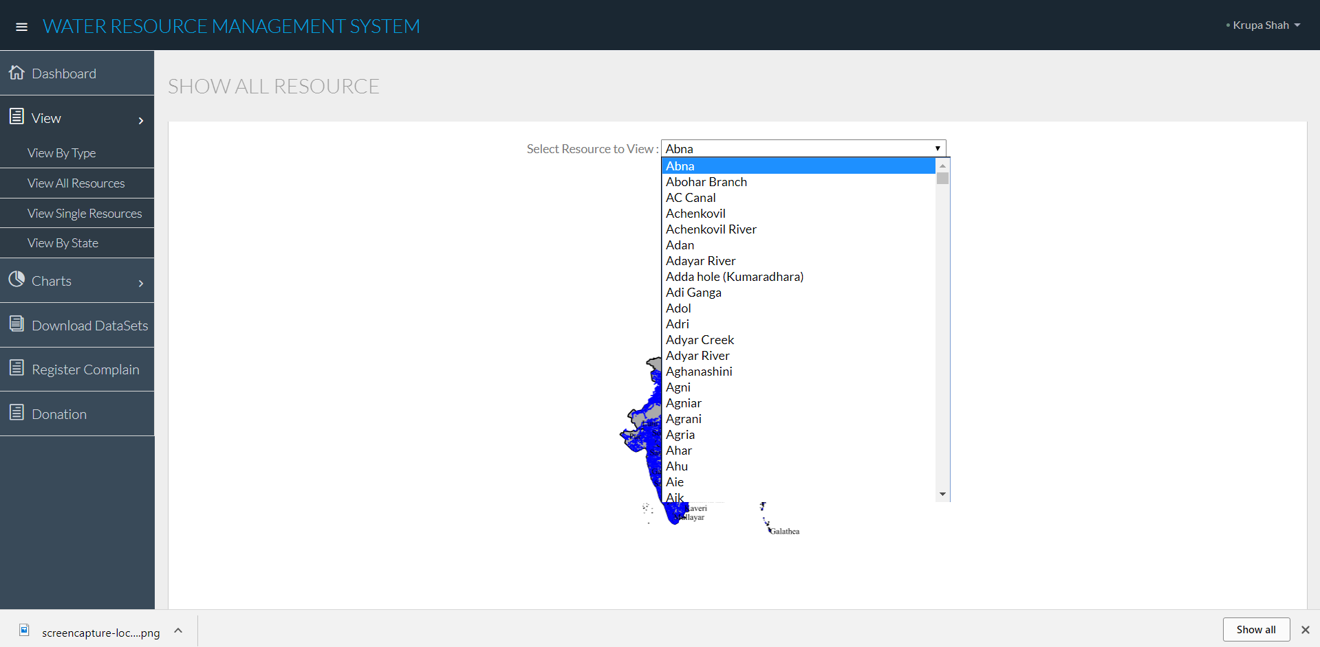

**Figure 5.1(10)**

Output of Figure 5.1(10):Shows the output of selected resource.

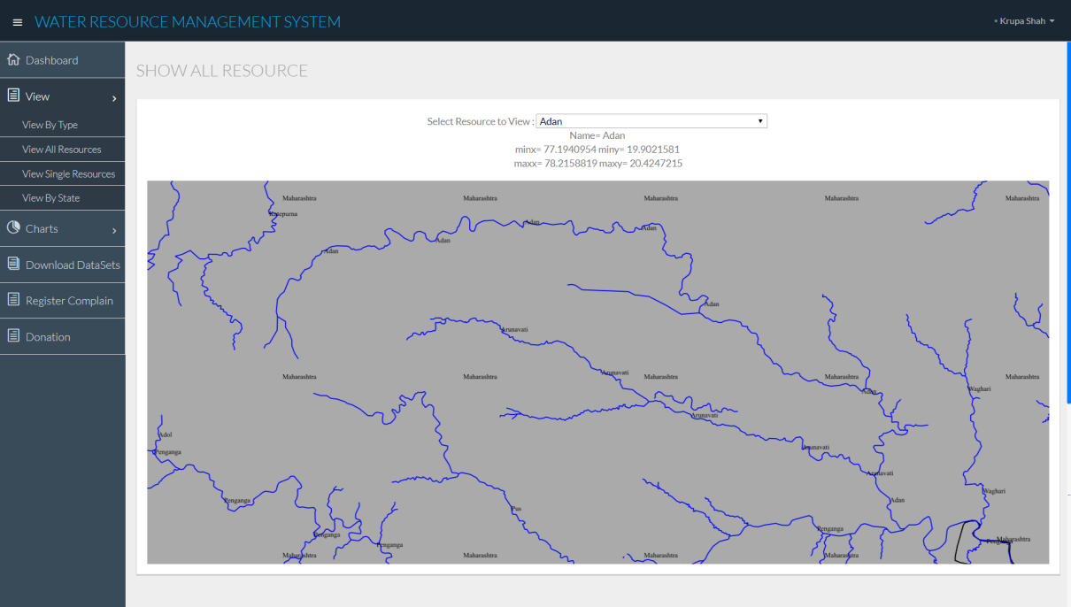

**Figure 5.1(11)**

* **View Single Resource:** User selects a particular type of resource from the dropdown list.

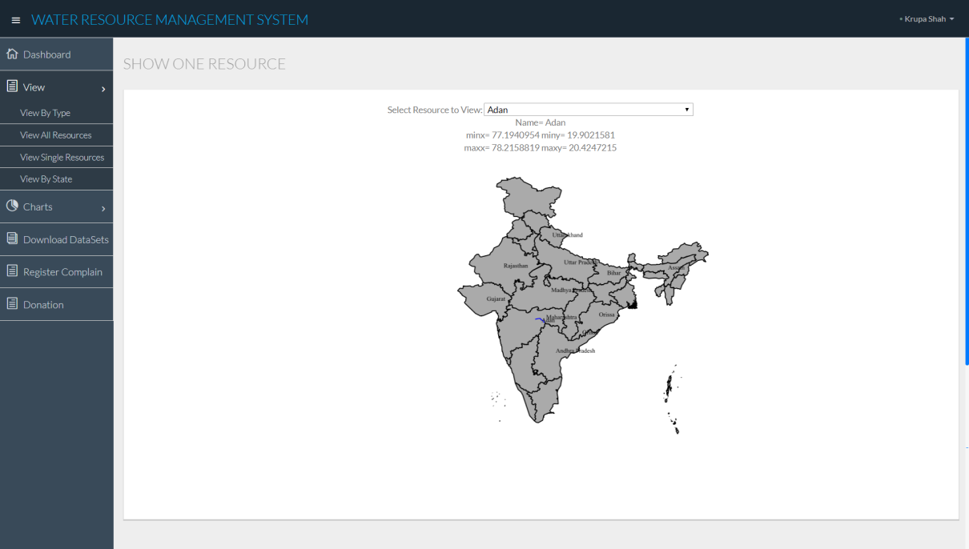

**Figure 5.1(12)**

* **View By State:** User selects a particular state from the dropdown list.

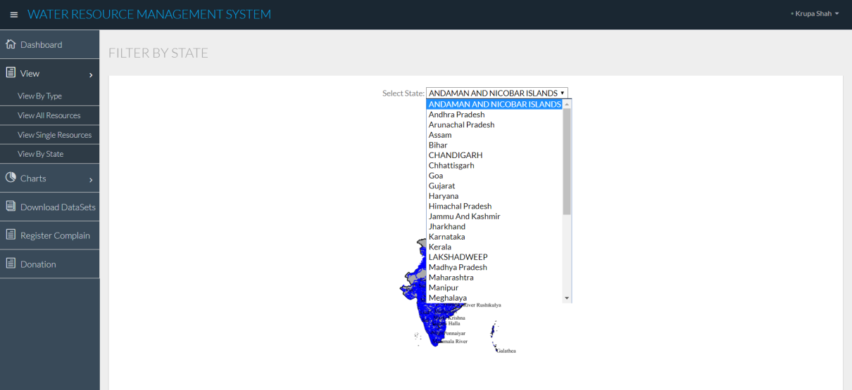

**Figure 5.1(13)**

The selected state is focused

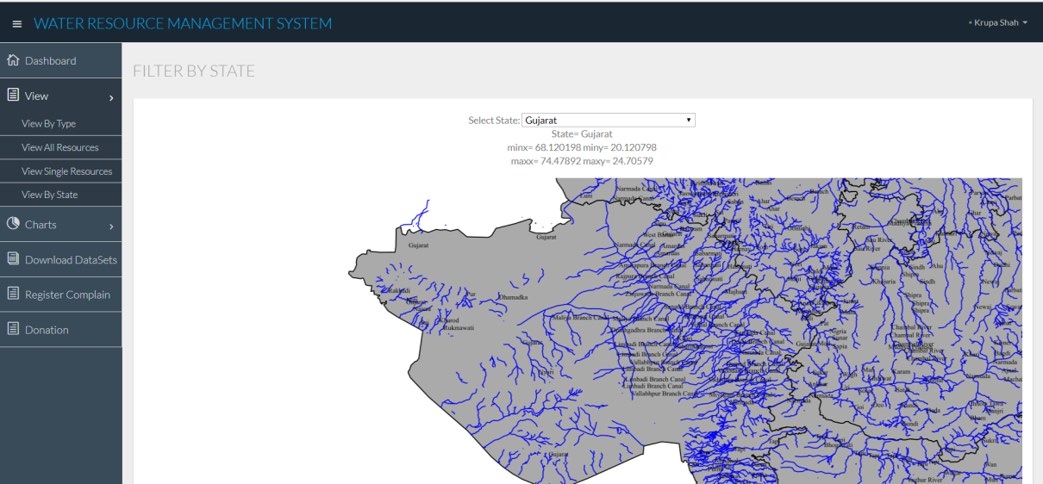

**Figure 5.1(14)**

The data of selected state is represented in gridview.

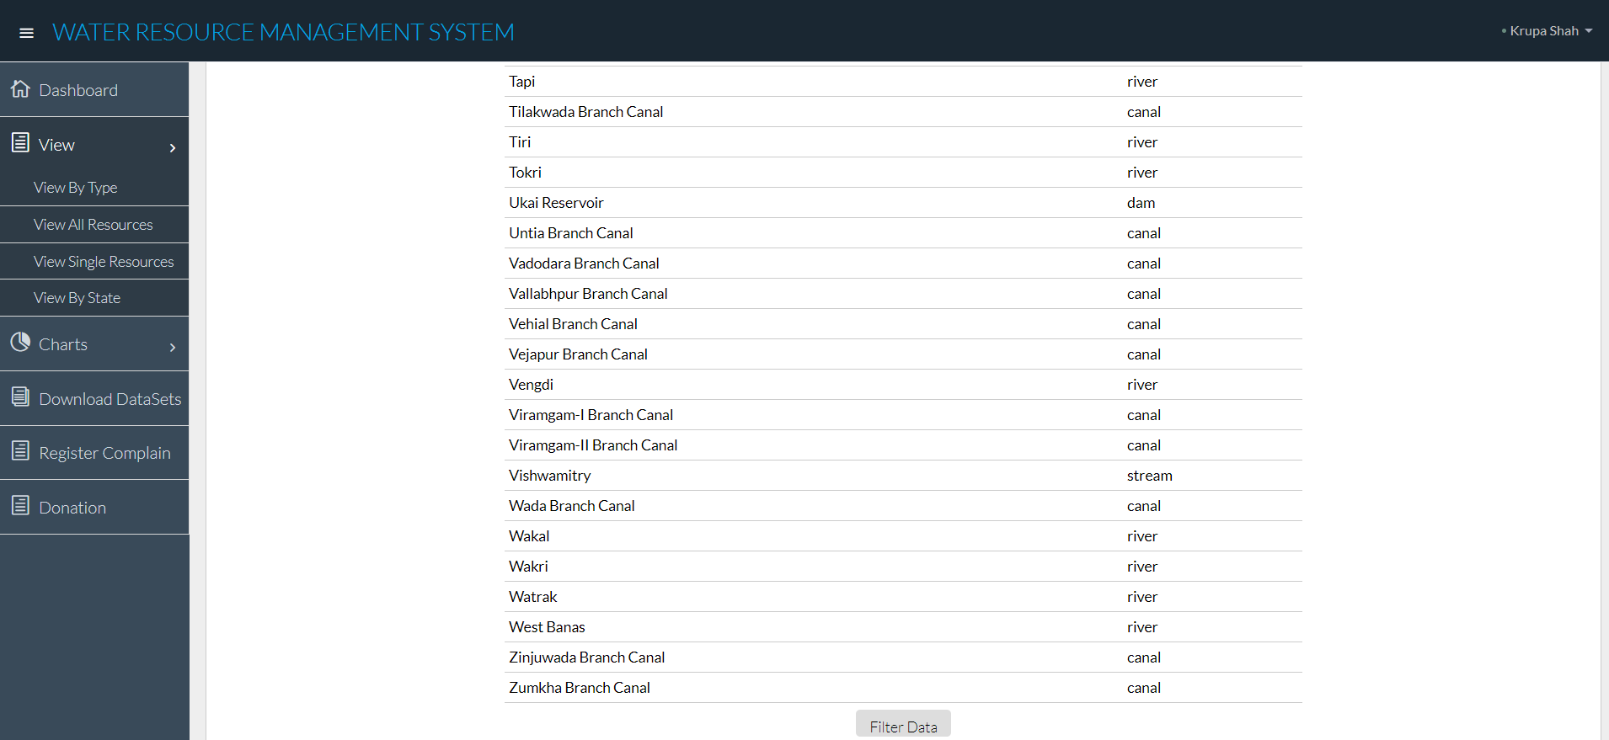

**Figure 5.1(15)**

* **View By State Filtering:** Page to apply filters to selected data

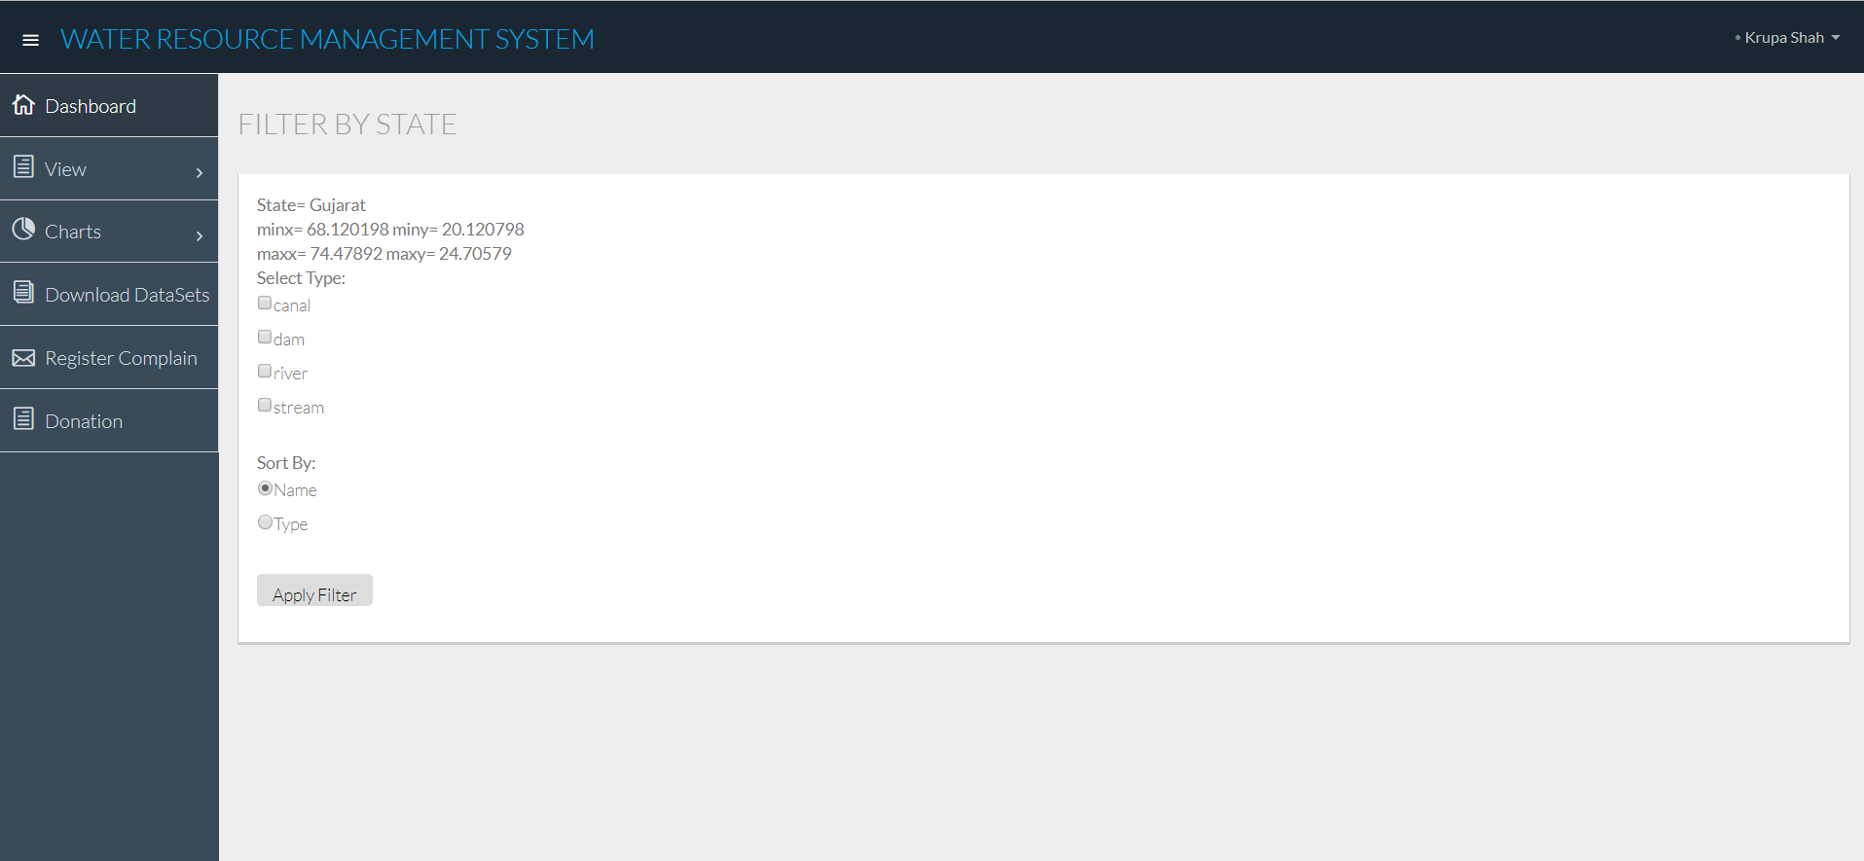

**Figure 5.1(16)**

Output of Figure5.1(16)

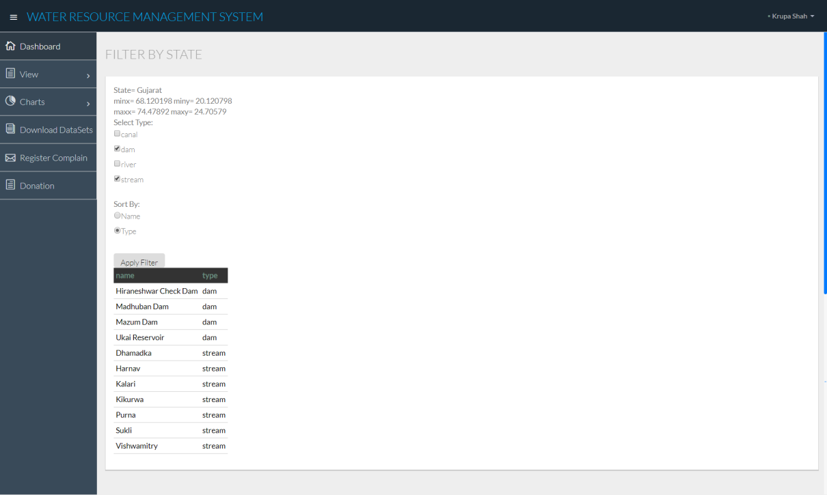

**Figure 5.1(17)**

* **Download File**

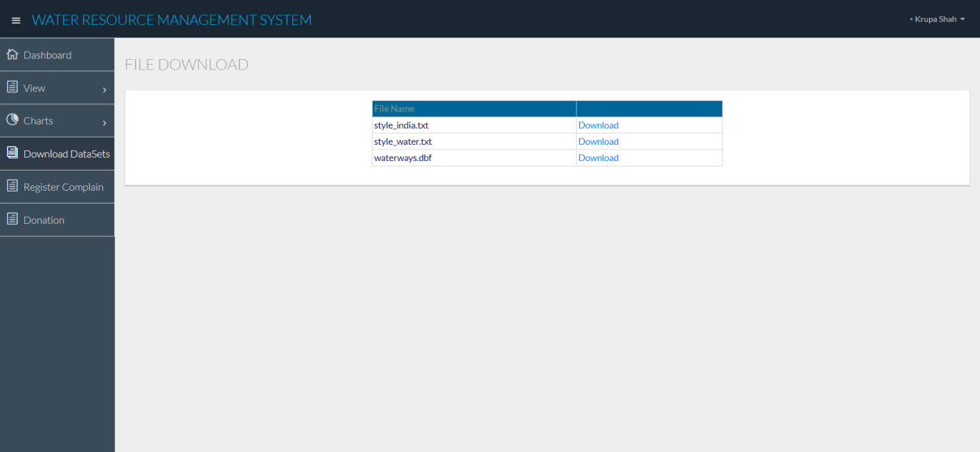

**Figure 5.1(18)**

* **Chart By Type:** On selection of particular type of resources, there are 4 different charts representing the same data.

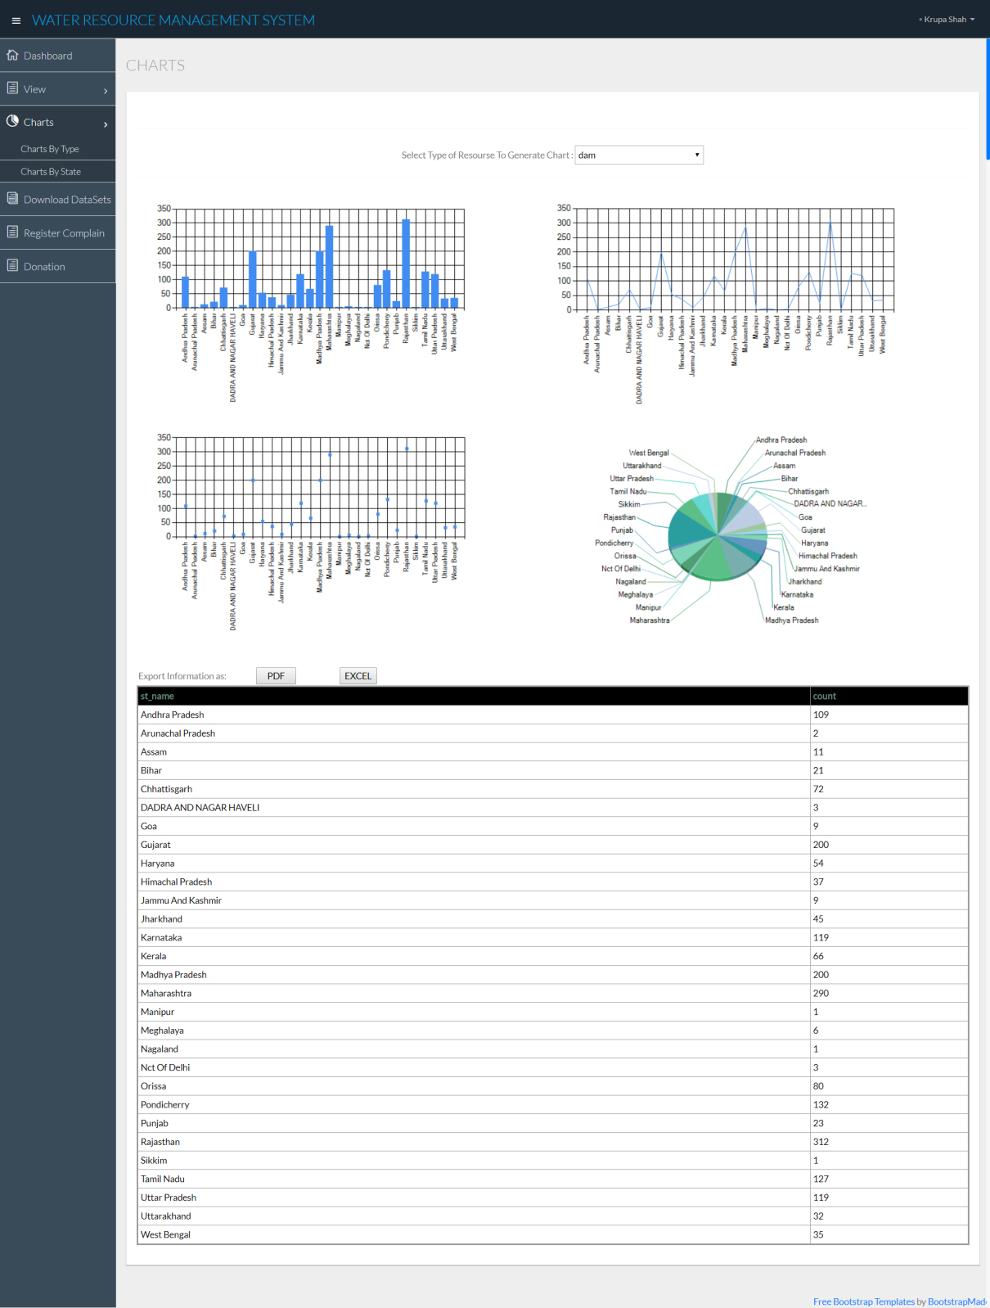

**Figure 5.1(19)**

* **Chart By State:** On selection of particular state, there are 4 different charts representing the same data.

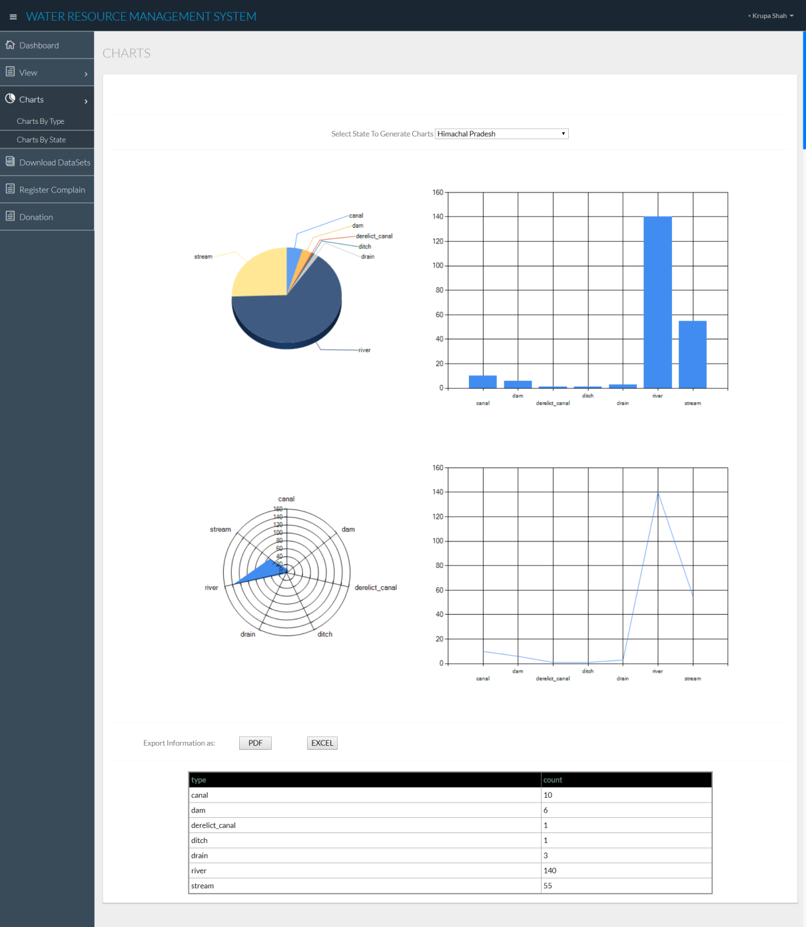

**Figure 5.1(20)**

* **PDF and EXCEL Button**

**+**

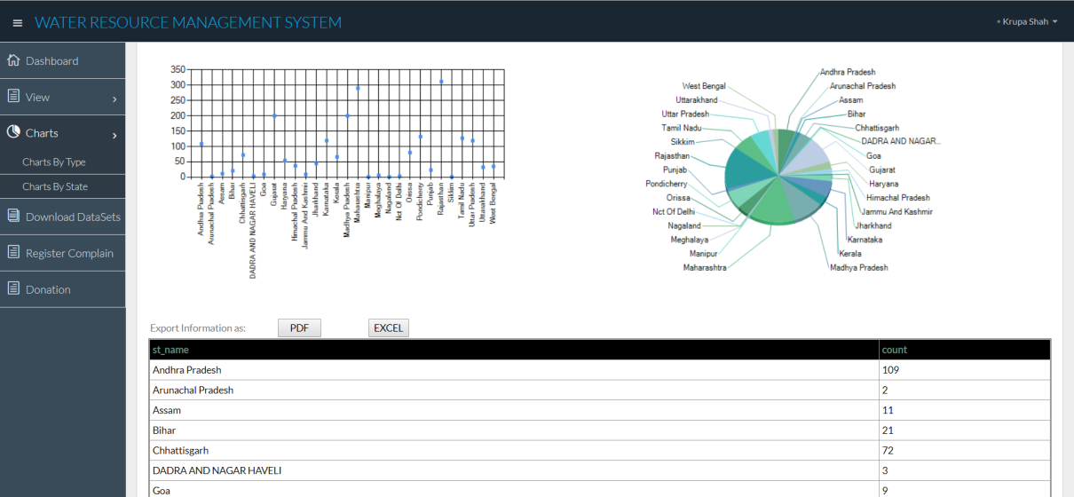

**Figure 5.1(21)**

* **Downloaded Data in EXCEL File**

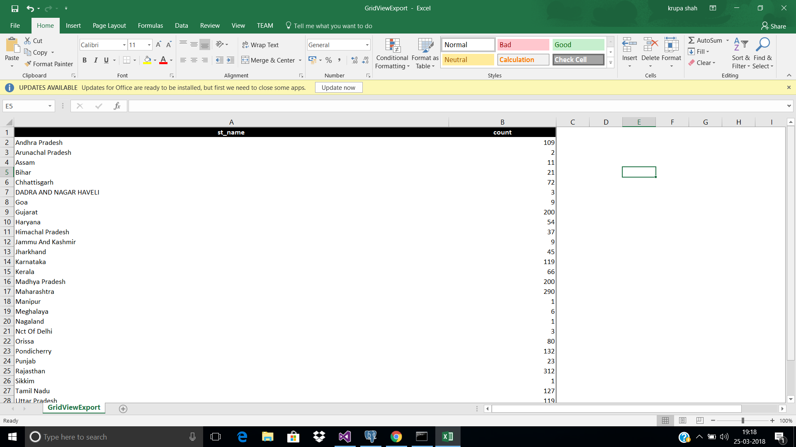

**Figure 5.1(22)**

* **Downloaded Data In PDF File**

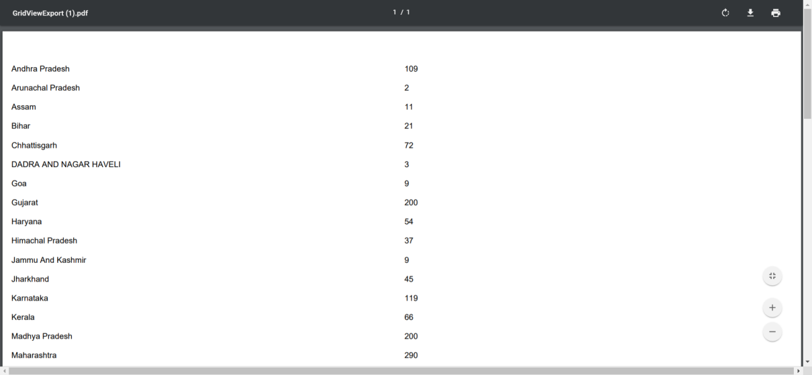

**Figure 5.1(23)**

* **Register Complaint Page**

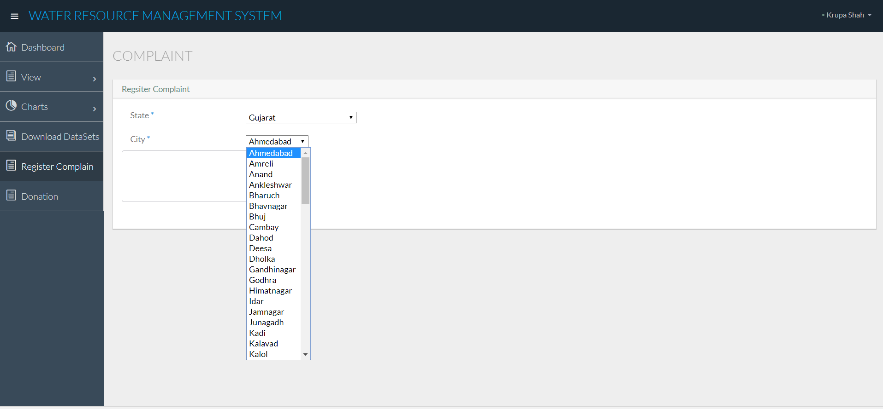

**Figure 5.1(24)**

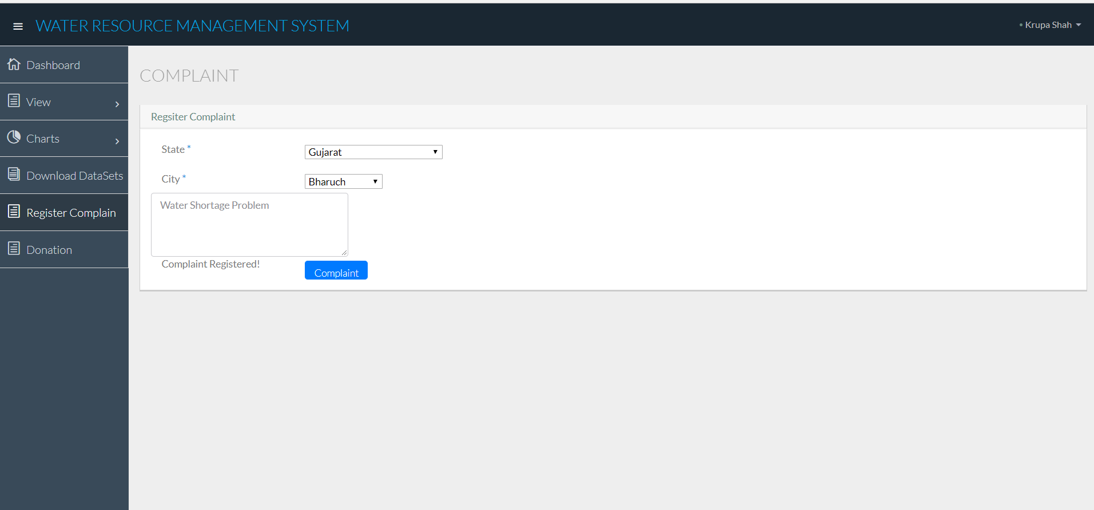

**Figure 5.1(25)**

* **Donation Page**

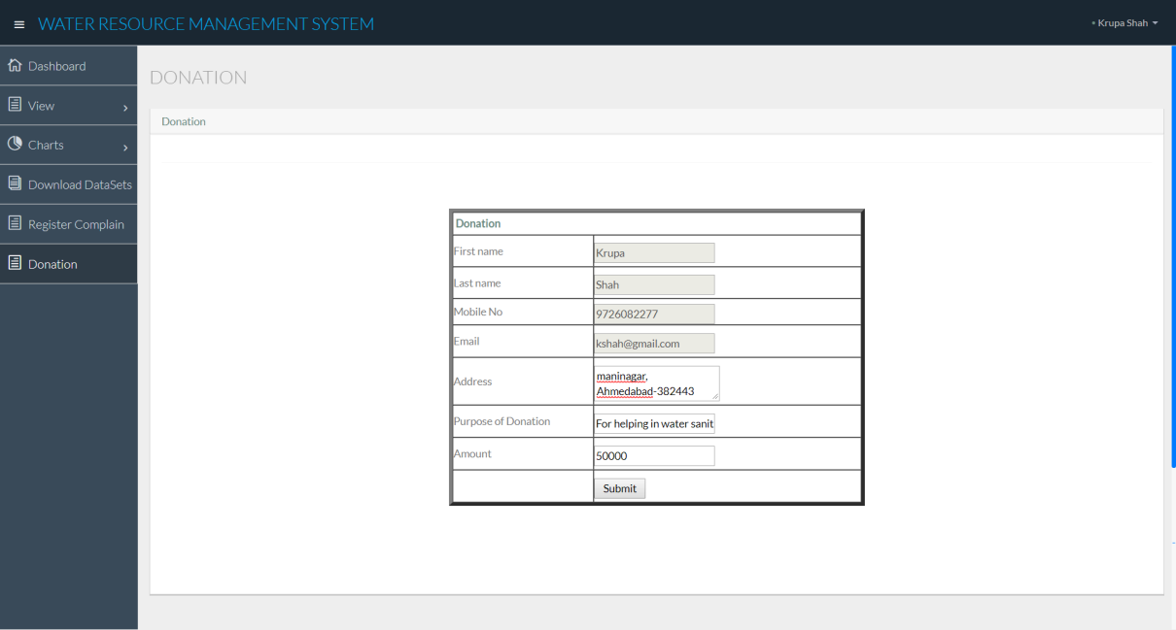

**Figure 5.1(26)**

* **Payment Page**

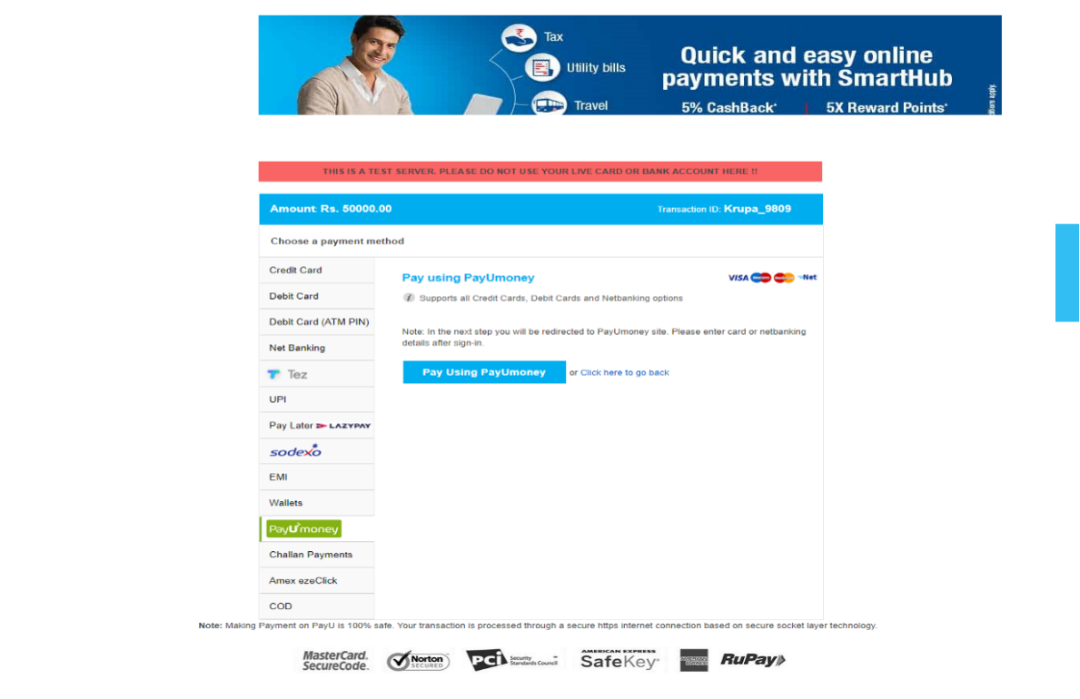

**Figure 5.1(27)**

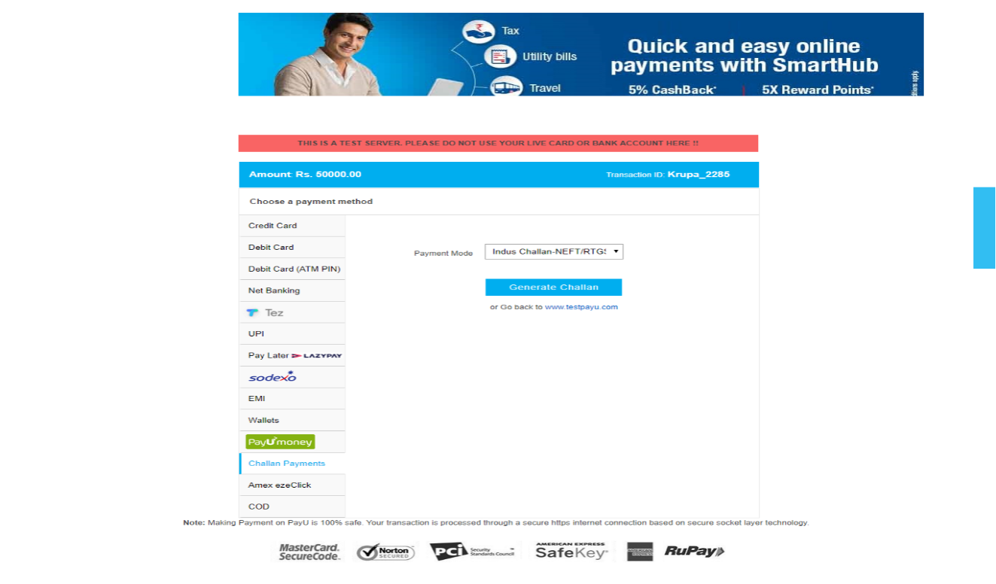

**Figure 5.1(28)**

* **Challan Receipt**

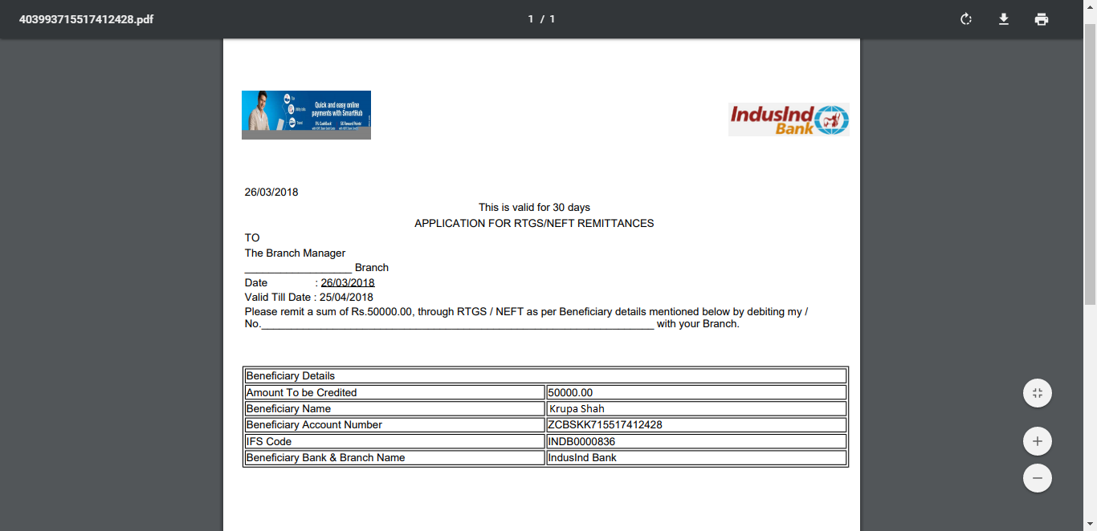

**Figure 5.1(29)**

* **Change Password**

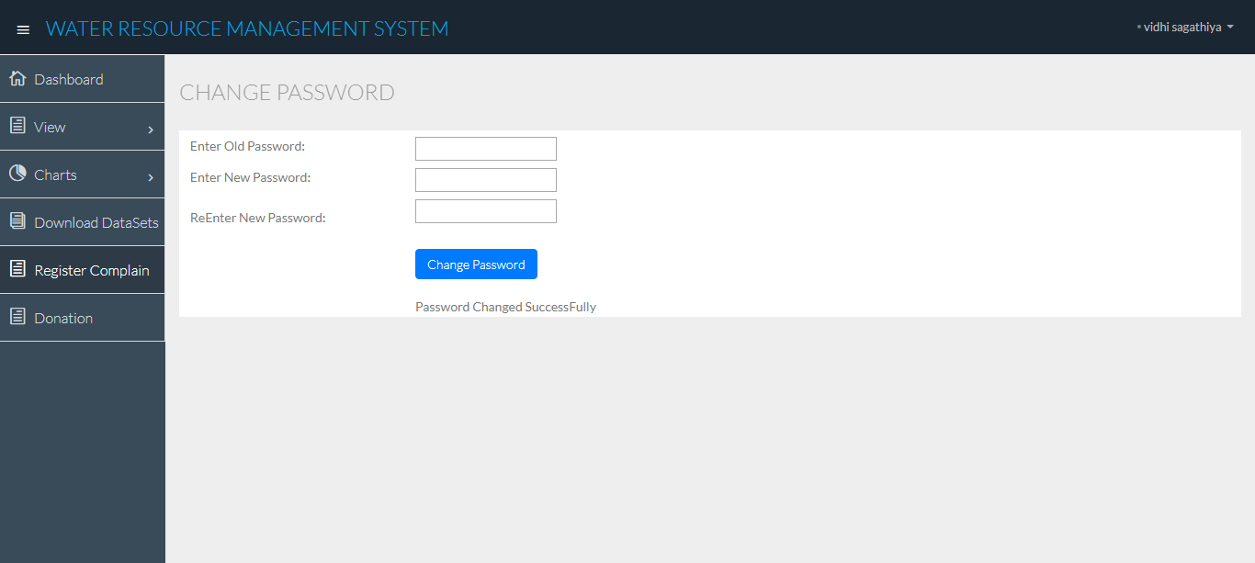

**Figure 5.1(30)**

* **Admin Home Page**

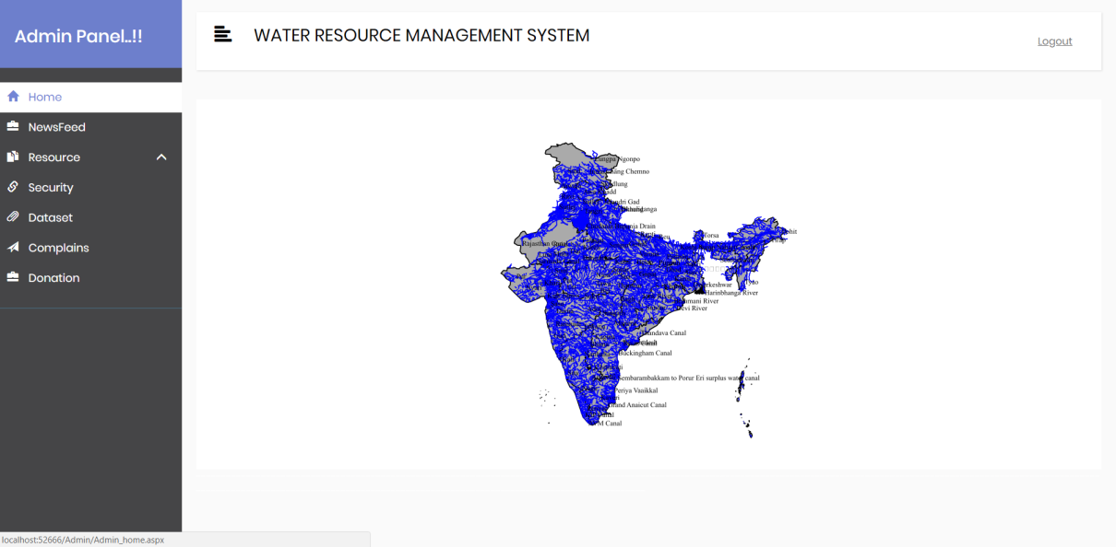

**Figure 5.1(31)**

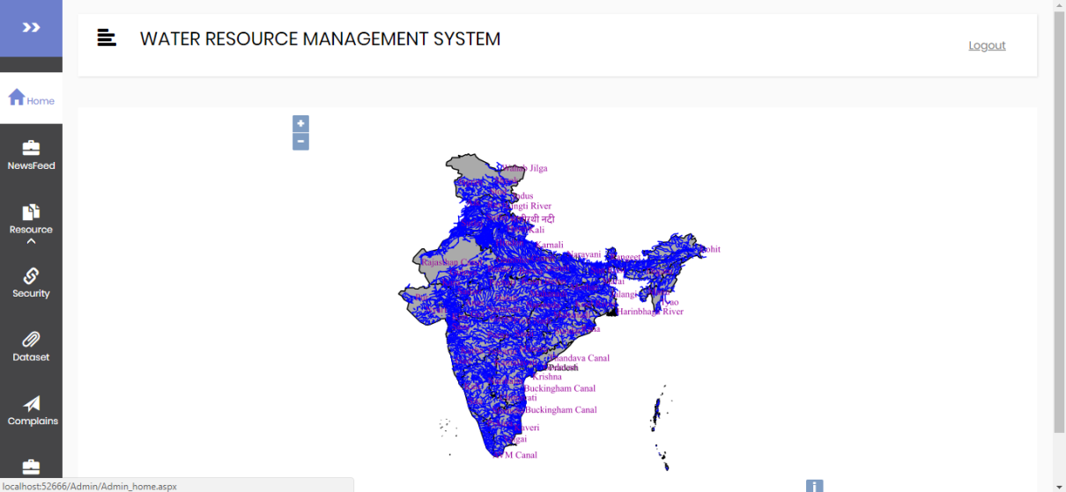

**Figure 5.1(32)**

* **Add News Feed Page**

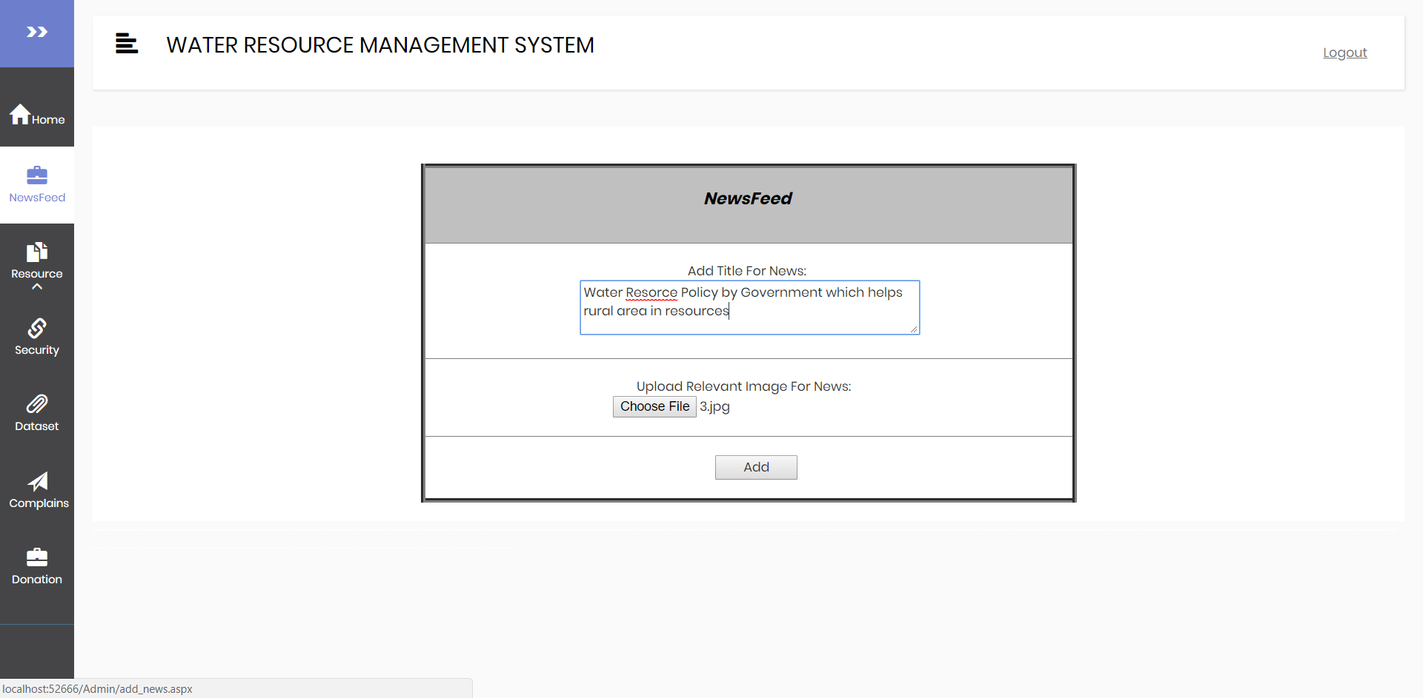

**Figure 5.1(33)**

* **Add Resource By UI**

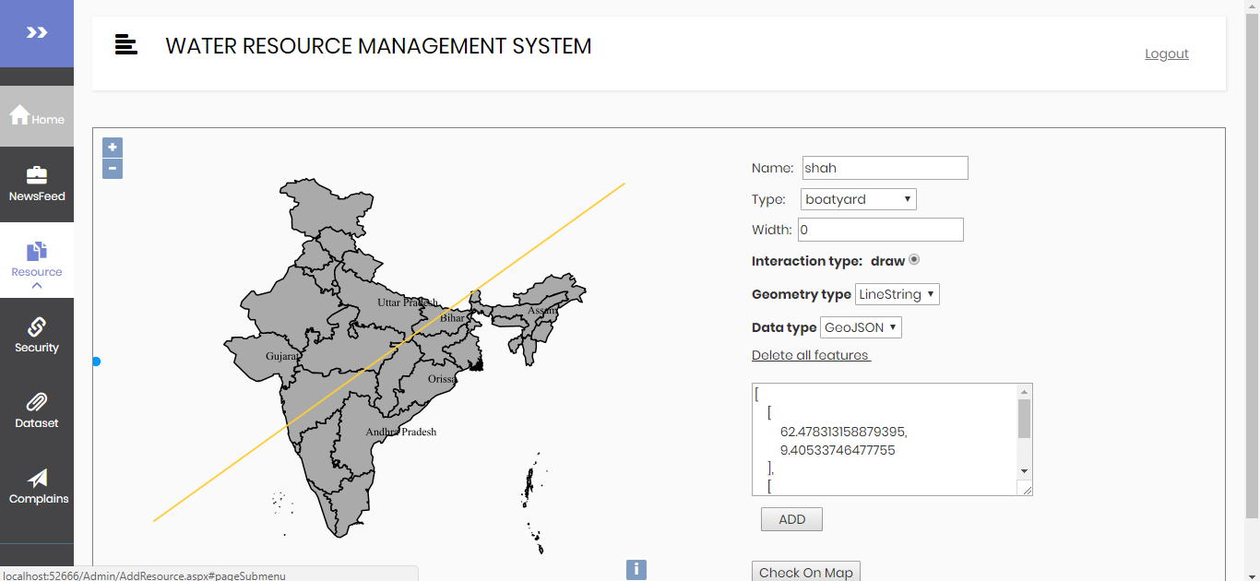

**Figure 5.1(34)**

Figure 5.1(35) shows that the data entered in Figure5.1(34) is successfully entered.

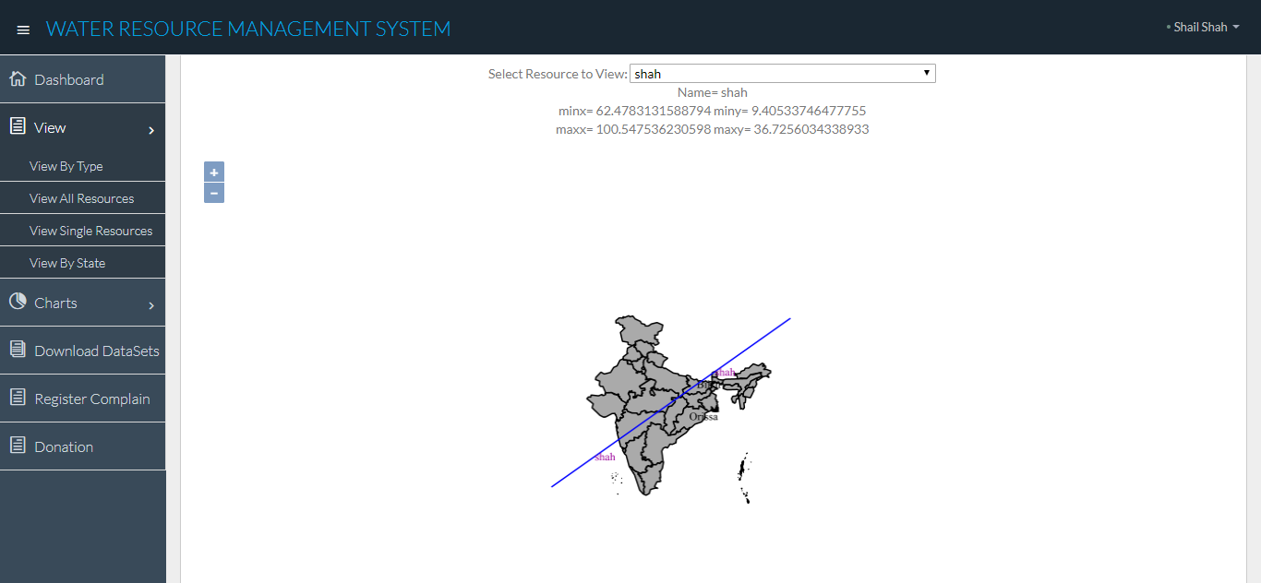

**Figure 5.1(35)**

* **Add Resource By Latitude and Longitude**

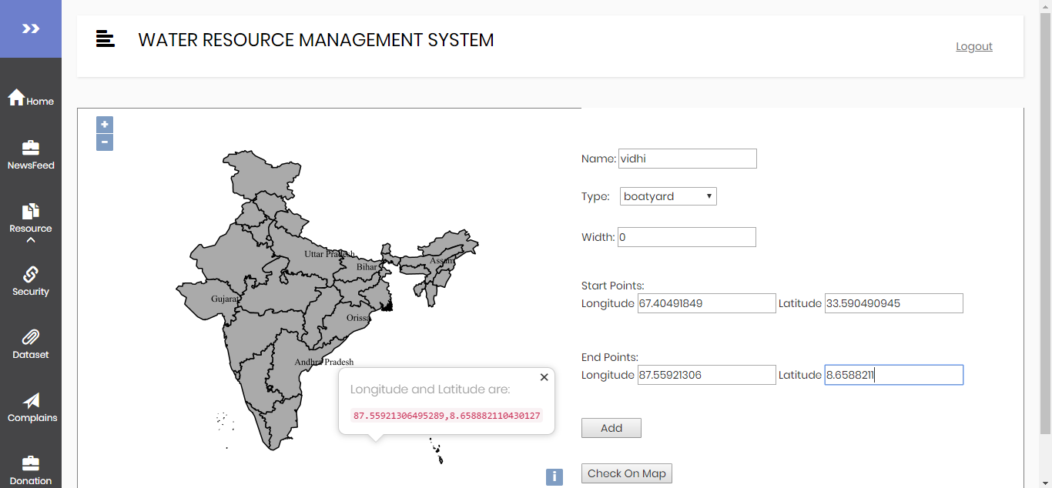

**Figure 5.1(36)**

Figure 5.1(37) shows that the data entered in Figure5.1(36) is successfully entered.

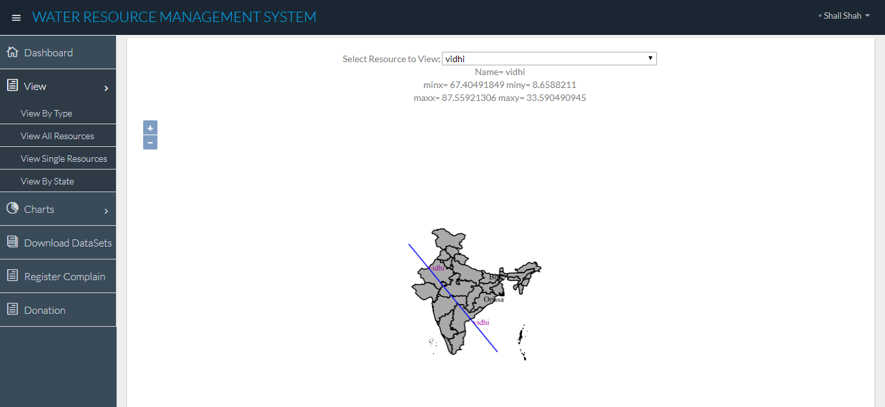

**Figure 5.1(37)**

* **Delete Resource**

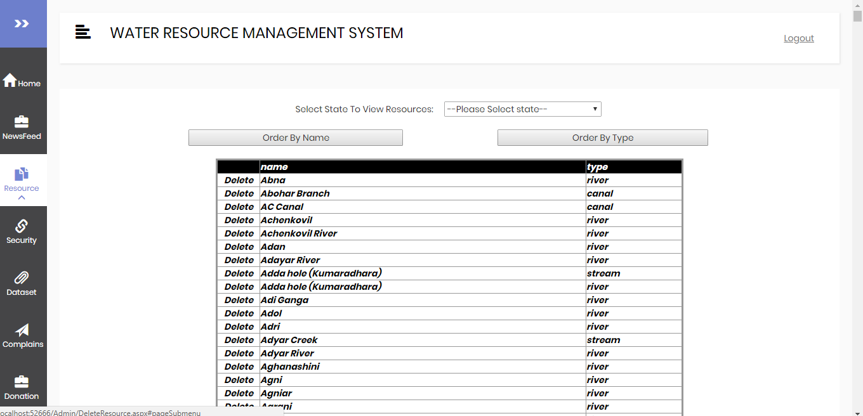

**Figure 5.1(38)**

Output after deleting first entry from Figure 5.1(38)

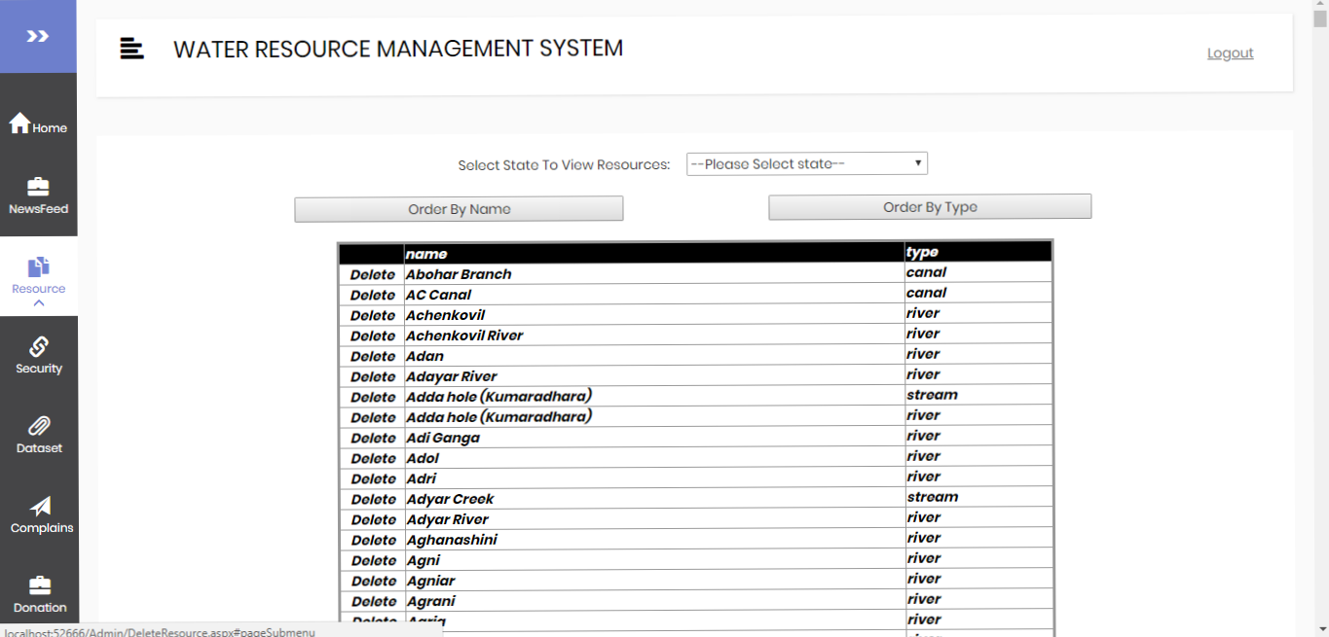

**Figure 5.1(39)**

* **Add Security Question**

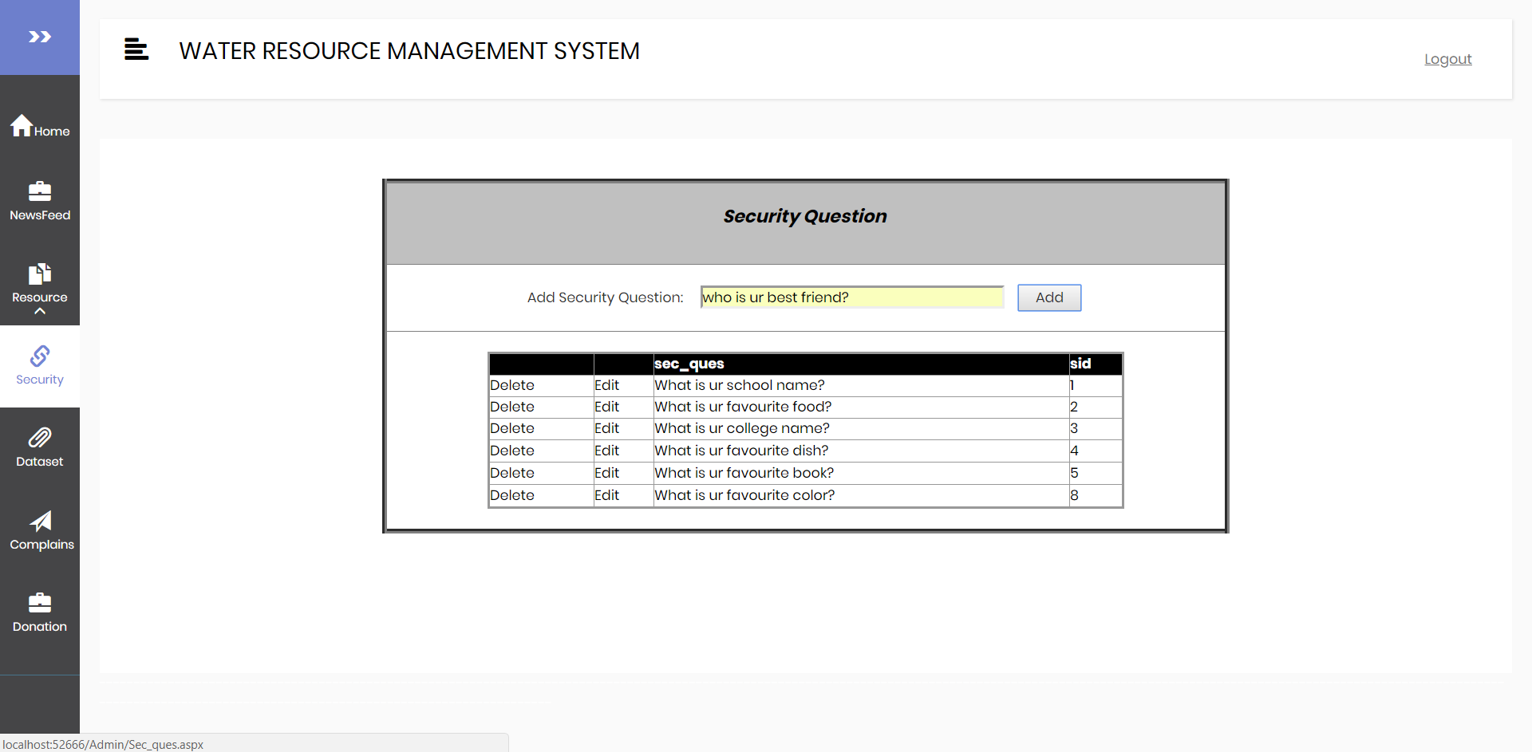

**Figure 5.1(40)**

Security Question added successfully.

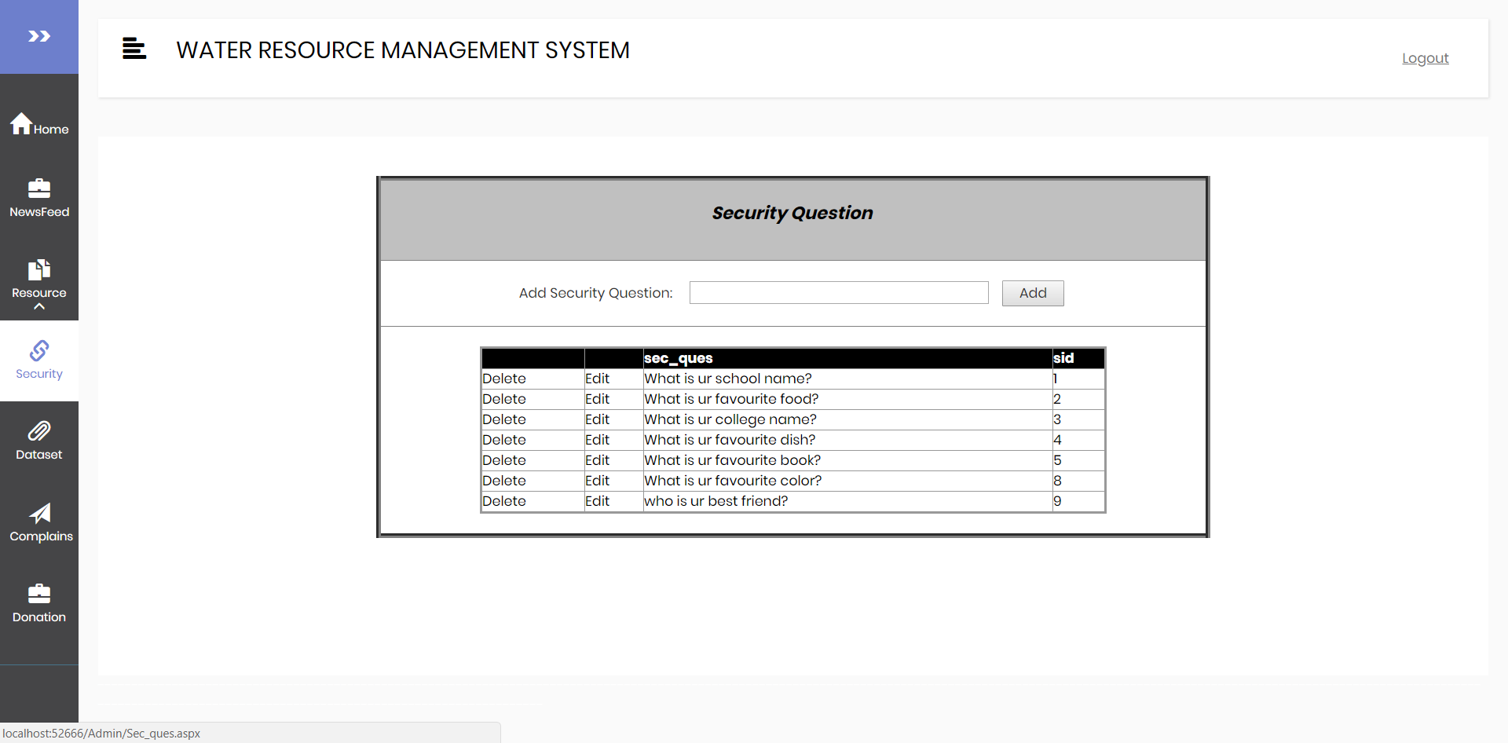

**Figure 5.1(41)**

* **File Upload and Delete Feature**

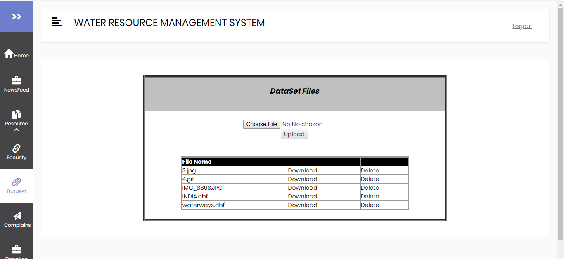

**Figure 5.1(42)**

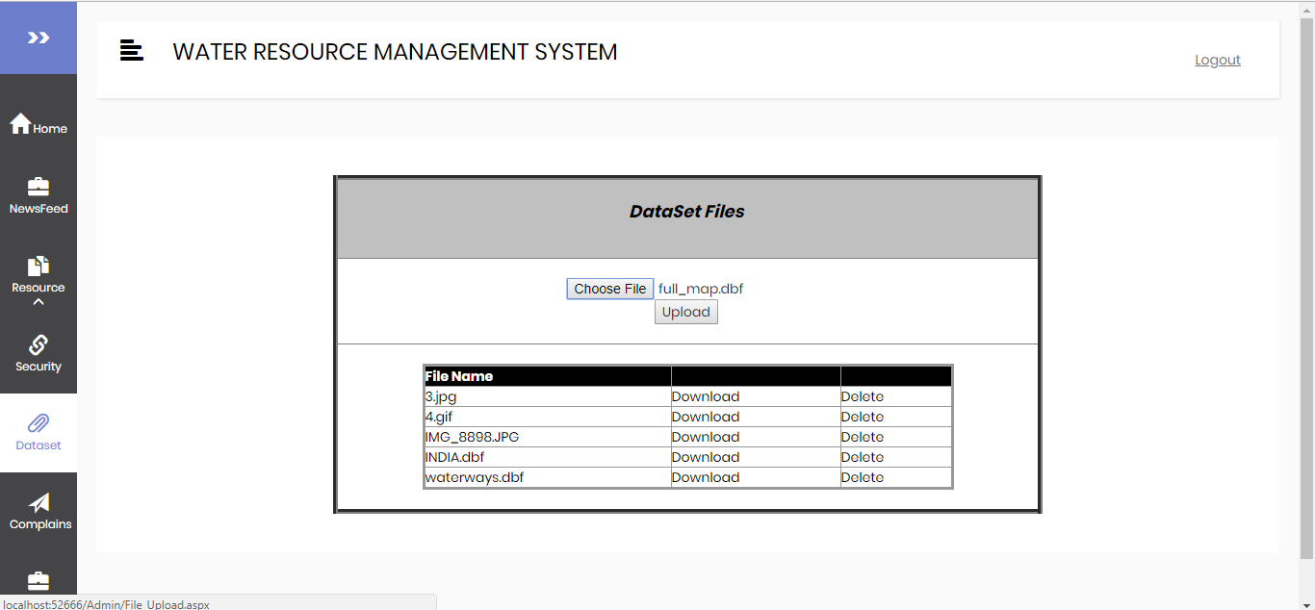

**Figure 5.1(43)**

* **View and Update Complaint Status**

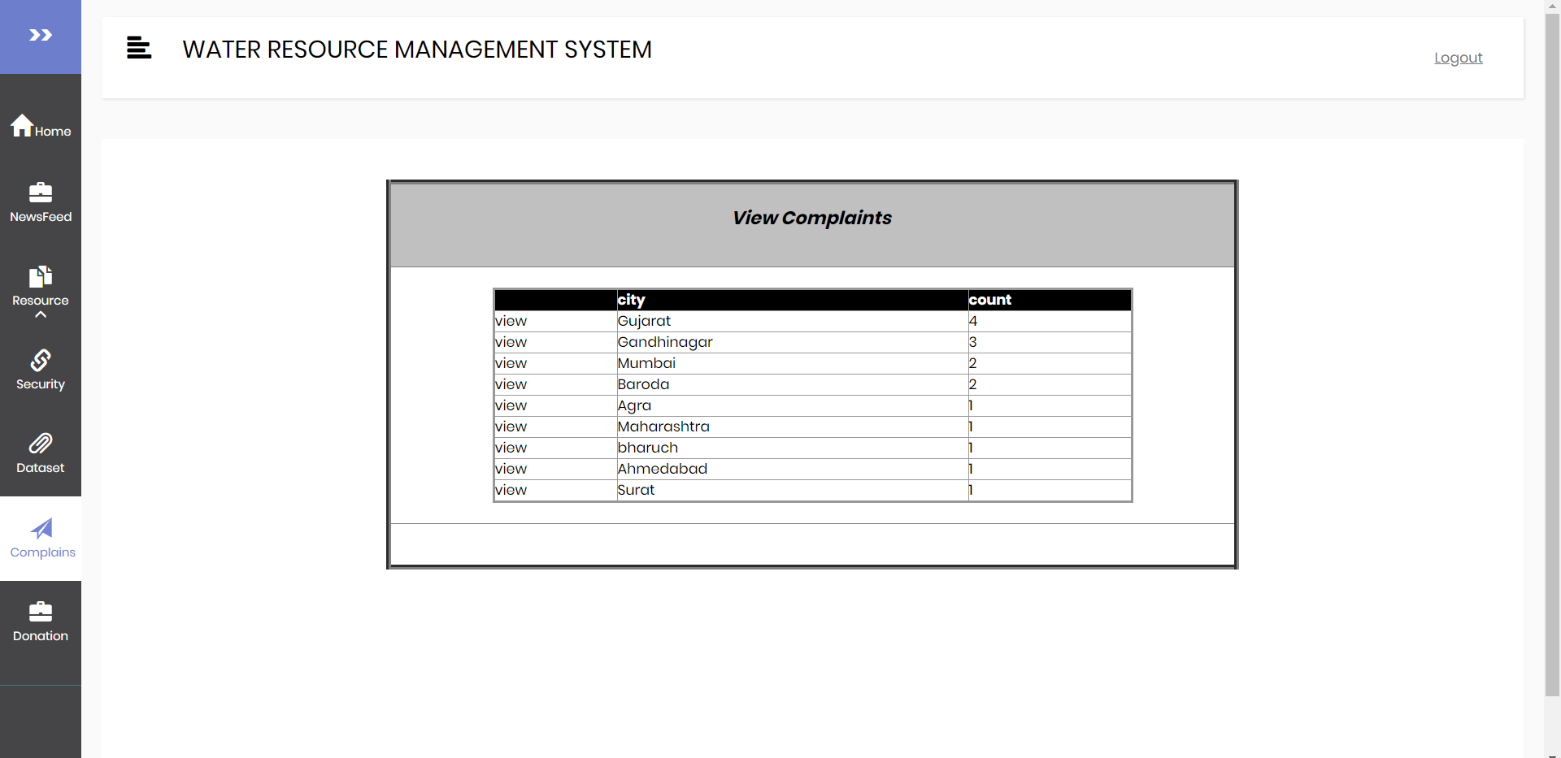

**Figure 5.1(44)**

On selection of particular city from Figure 5.1(44) new table is generated showing complaints from that particular city.

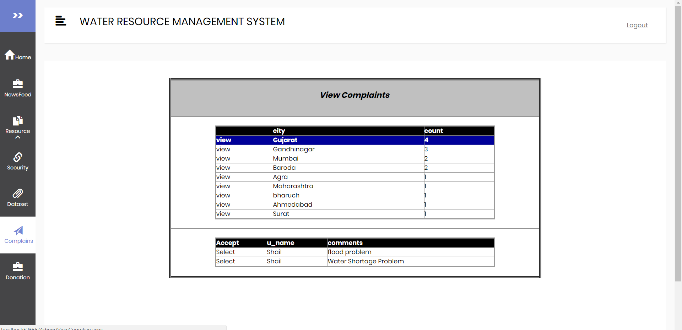

**Figure 5.1(45)**

The highlighted complaint shows that the complain is viewed and status has been changed.

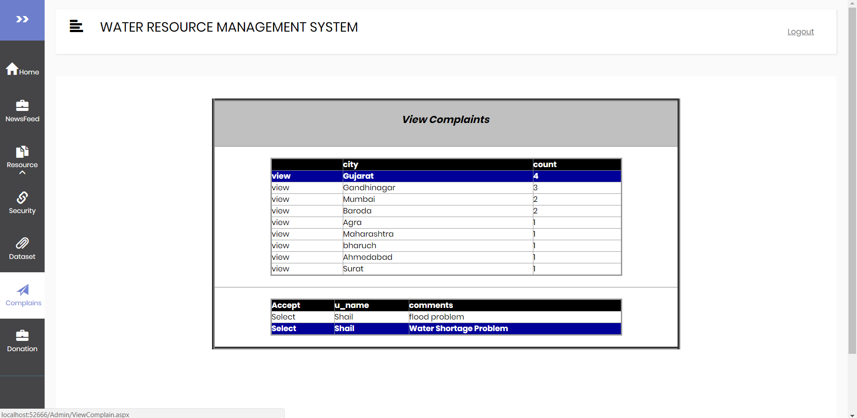

**Figure 5.1(46)**

* **View and Donations**

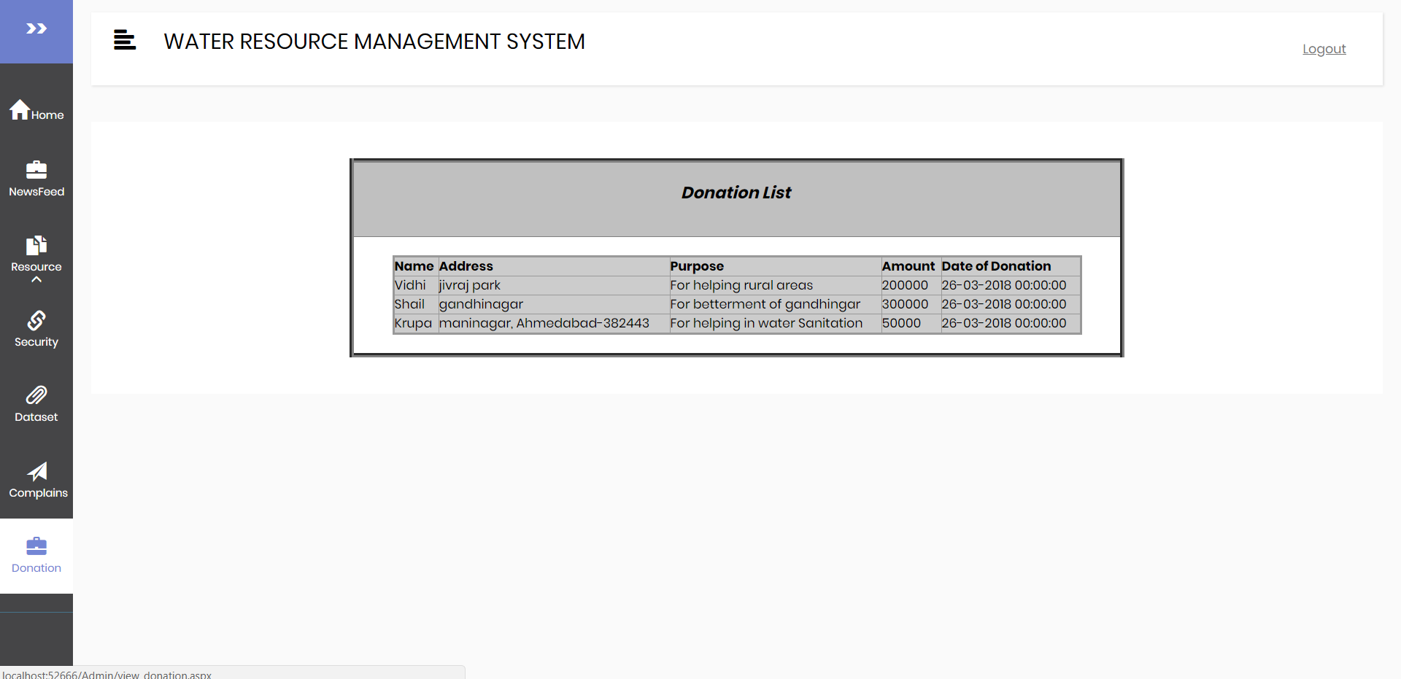

**Figure 5.1(47)**

Chapter 6

System Testing ________________________________________________________________________

**6.1 TESTING STRATEGY**

Analyze and check system representations such as the requirements document, design diagrams and the program source code. They are applied at all stages of the process.

The following diagram shows different types of testing applied to the project:

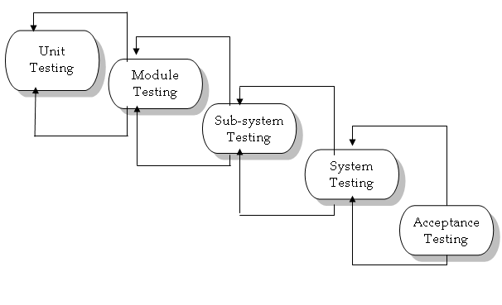

**6.2 TESTING METHODS**

There are several models for testing module some of them are as follows:

**Black-box Testing**

**6.2.1 Test Cases**

|  |  |  |  |  |
| --- | --- | --- | --- | --- |
| Test Case | Module Name | Input | Expected Result | Test Result |
| 1 | Login | 1. Enter valid email and  password | Site should display Dashboard | As expected |
|  |  | 2. Enter invalid email  and valid password | Site should display  Error Message  Invalid credentials | Error  Message  Shown |
|  |  | 3. Enter invalid email  and invalid password | Site should display  Error Message  Invalid credentials | Error  Message  Shown |
|  |  | 4. Enter valid email  and invalid password | Site should display  Error Message  Invalid credentials | Error  Message  Shown |
|  |  | 5. Without  entering login  information | Site should display  Error Message Please  enter email and password | Error  Message  Shown |

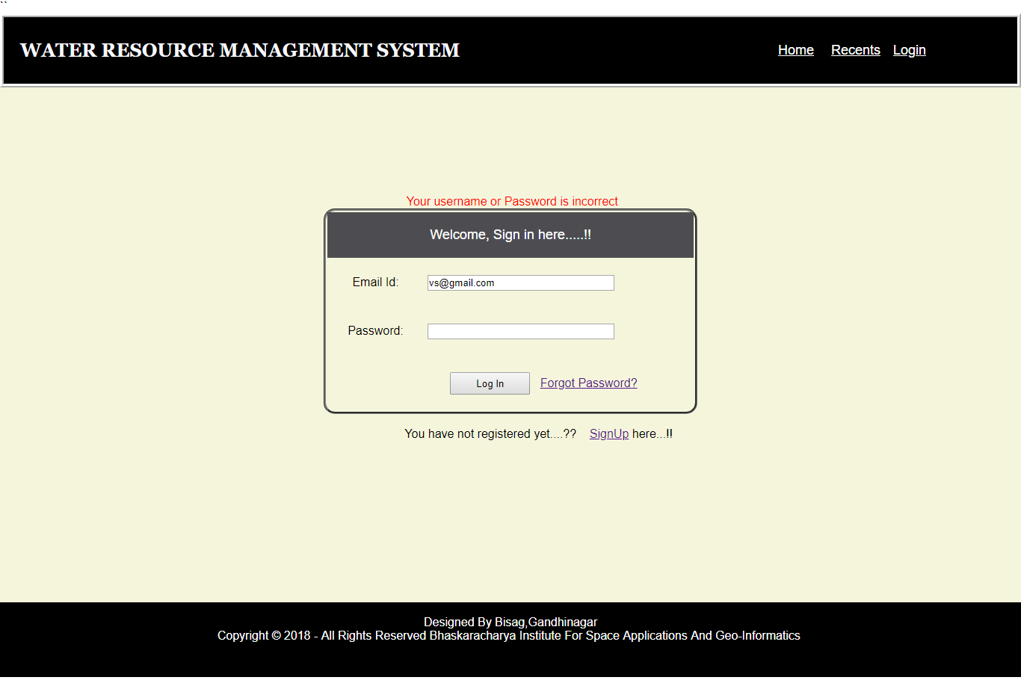

**Figure 6.2.1(1)**

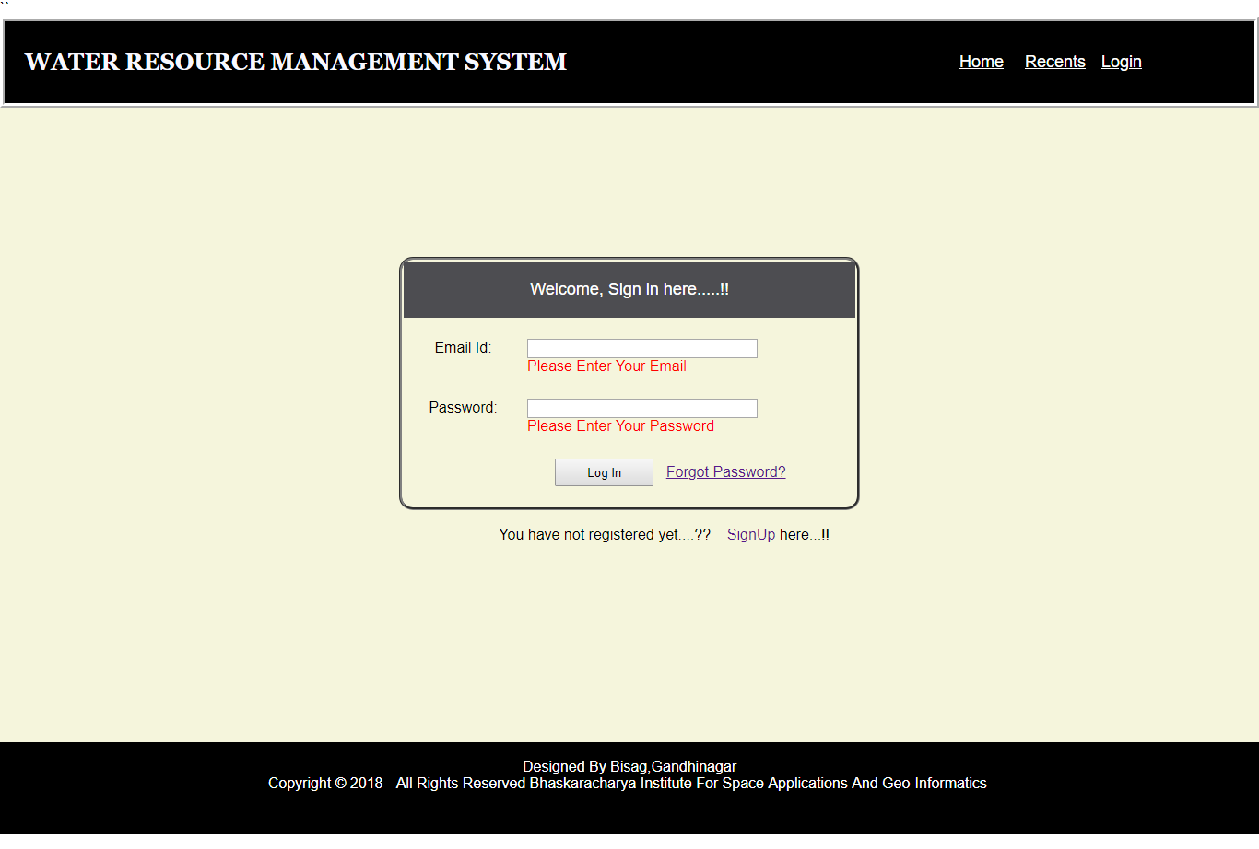

**Figure 6.2.1(2)**

|  |  |  |  |  |
| --- | --- | --- | --- | --- |
| 2 | Sign Up | 1. Enter valid  information | Site should display Dashboard | As expected |
|  |  | 2. Enter invalid  mobile number | Site should display  Error Message Invalid mobile number | Error  Message  Shown |
|  |  | 3. Enter invalid  Email id | Site should display  Error Message Invalid email id | Error  Message  Shown |
|  |  | 4. Without entering  few/any information | Site should display Error Message field is required | Error  Message  Shown |

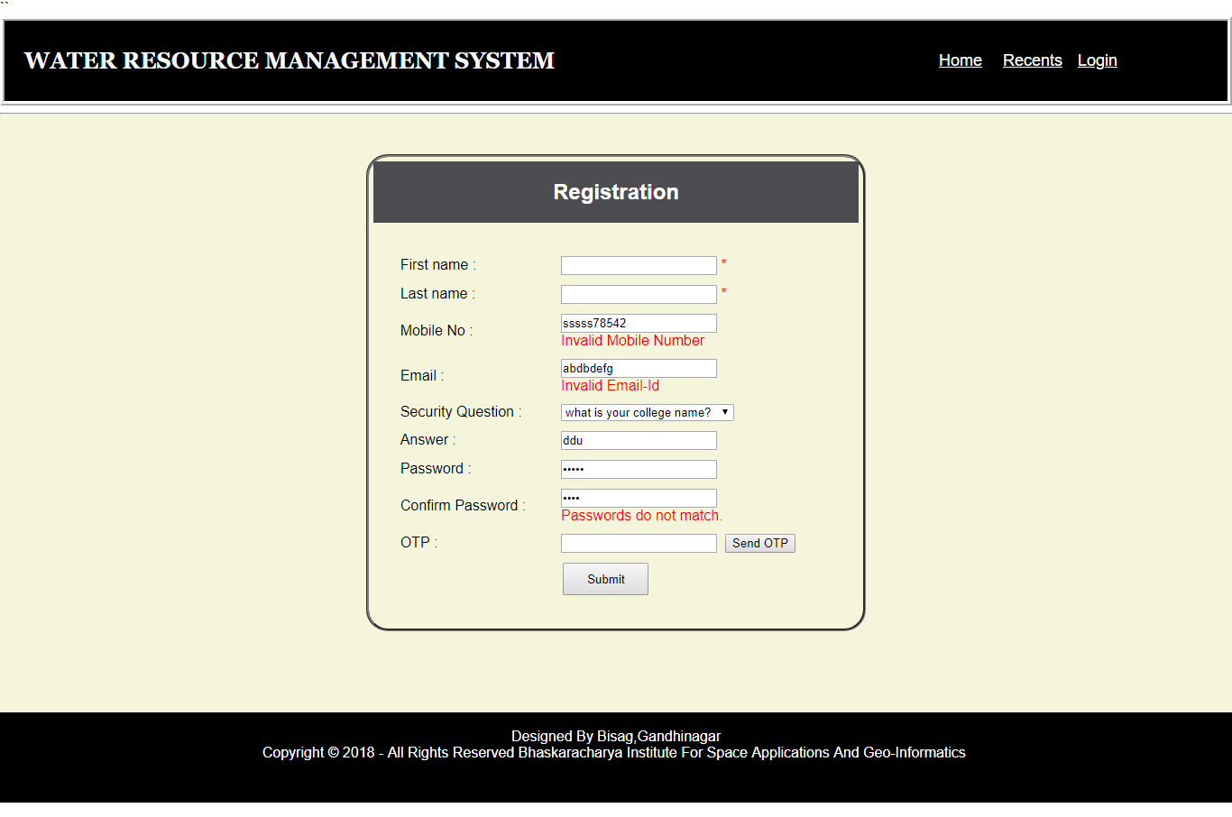

**Figure 6.2.1(3)**

|  |  |  |  |  |
| --- | --- | --- | --- | --- |
| 3 | Change Password | 1. Enter valid old password and new password | Site should display Success Message | As expected |
|  |  | 2. Enter invalid old password and new password | Site should display Error Message Enter valid password | Error  Message  Shown |
|  |  | 3. Without entering  few/any information | Site should display Error Message field is required | Error  Message  Shown |

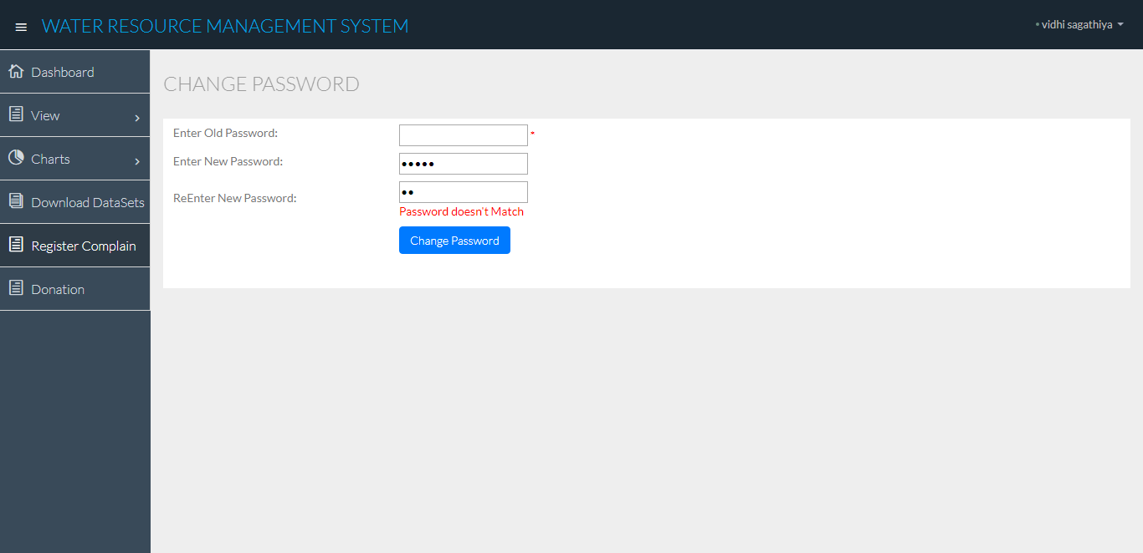

**Figure 6.2.1(4)**

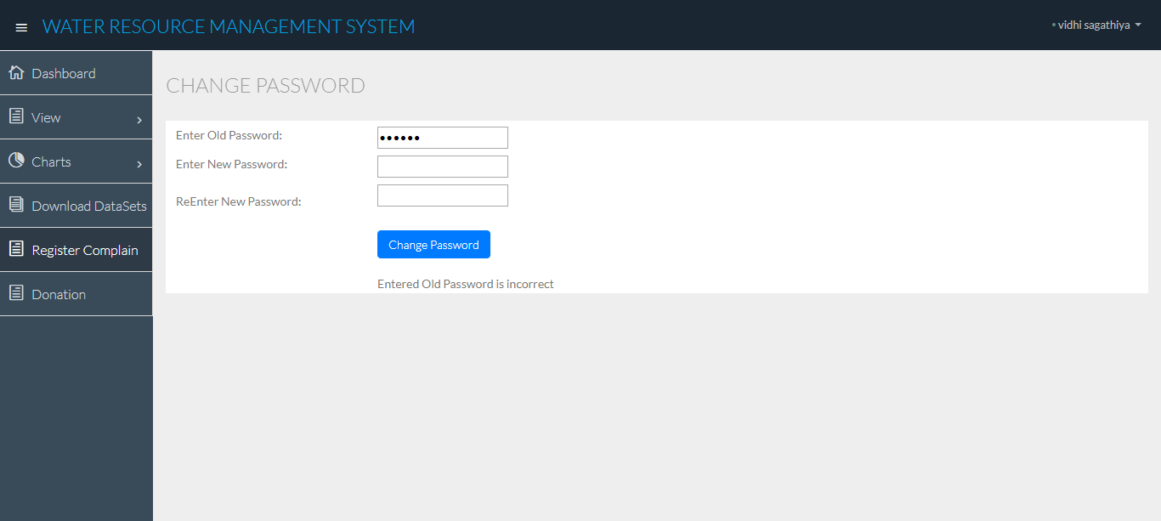

**Figure 6.2.1(5)**

|  |  |  |  |  |
| --- | --- | --- | --- | --- |
| 4 | Forgot Password | 1. Enter valid email id and security question | Site should display Password. | As expected |
|  |  | 2. Enter invalid email id and security question | Site should display Error Your credentials are incorrect | Error  Message  Shown |
|  |  | 3. Without entering  few/any information | Site should display Error Message field is required | Error  Message  Shown |

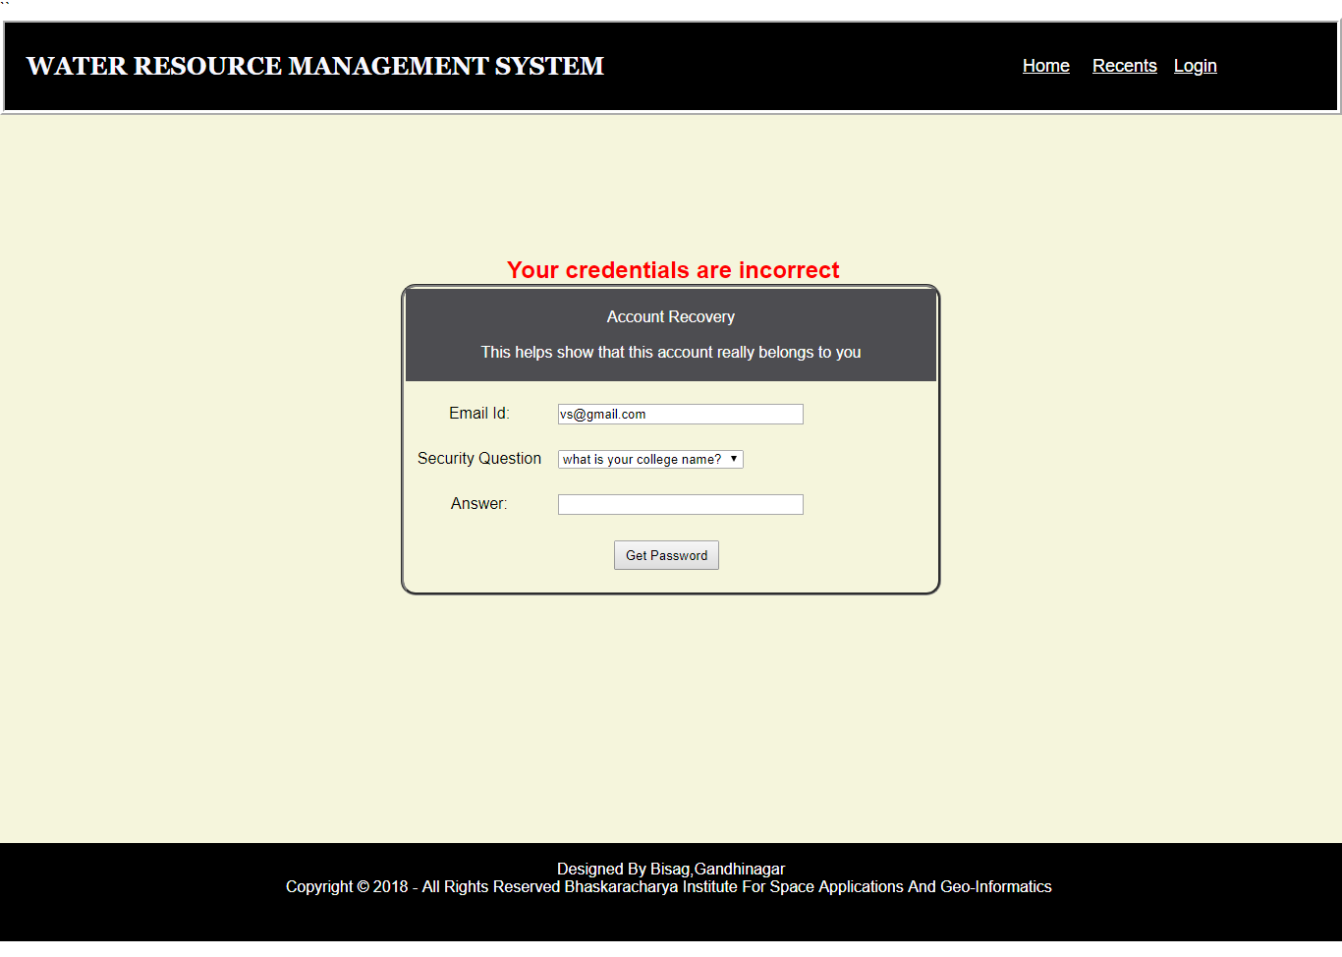

**Figure 6.2.1(6)**

|  |  |  |  |  |
| --- | --- | --- | --- | --- |
| 5 | Complaint | 1. Enter valid  Information | Site should display Success Message | As expected |
|  |  | 2. Without entering complaint | Site should display Error Message complaint field required | Error  Message  Shown |

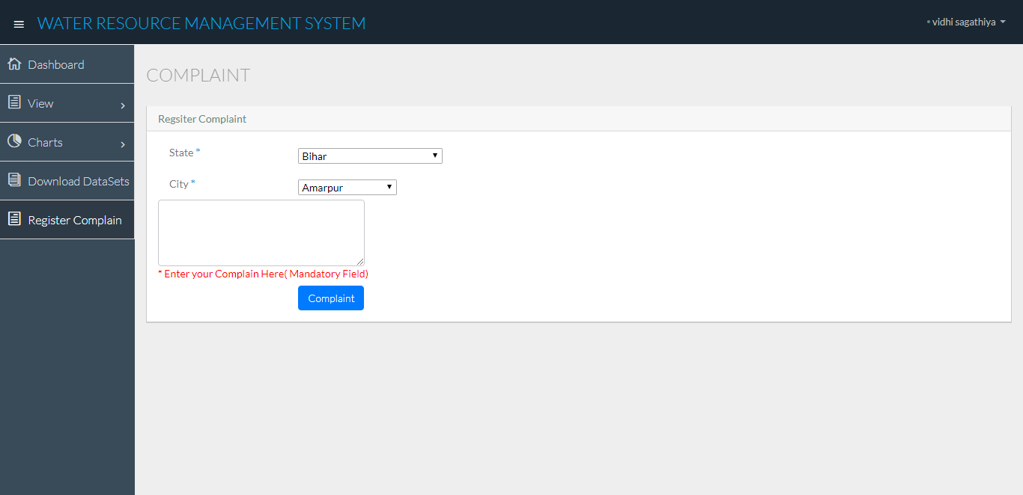

**Figure 6.2.1(7)**

|  |  |  |  |  |
| --- | --- | --- | --- | --- |
| 6 | Donation | 1. Enter valid data | Site should display payment receipt | As expected |
|  |  | 2. Without entering  few/any information | Site should display Error Message field is required | Error  Message  Shown |

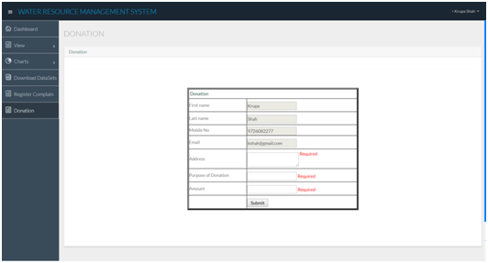

**Figure 6.2.1(8)**

|  |  |  |  |  |
| --- | --- | --- | --- | --- |
| 7 | File Upload | 1. Select file with size less than 100 Mb | Site should Upload the file | As expected |
|  |  | 2. Select file with size more than 100 Mb | Site should Upload the file | Error  Message  Shown |

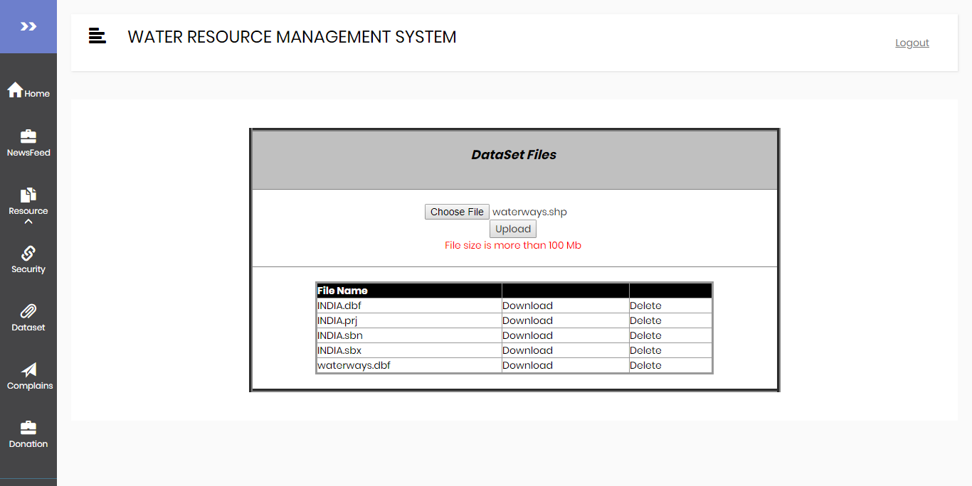

**Figure 6.2.1(9)**

|  |  |  |  |  |
| --- | --- | --- | --- | --- |
| 8 | News feed | 1. Enter valid data | Site should display Success Message | As expected |
|  |  | 2. Without entering  few/any information | Site should display Error Message field is required | Error  Message  Shown |

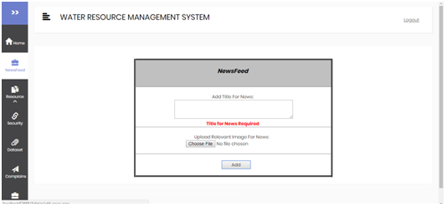

**Figure 6.2.1(10)**

|  |  |  |  |  |
| --- | --- | --- | --- | --- |
| 9 | Add Resource | 1. Enter valid data | Site should display Success Message | As expected |
|  |  | 2. Without entering  few/any information | Site should display Error Message field is required | Error  Message  Shown |

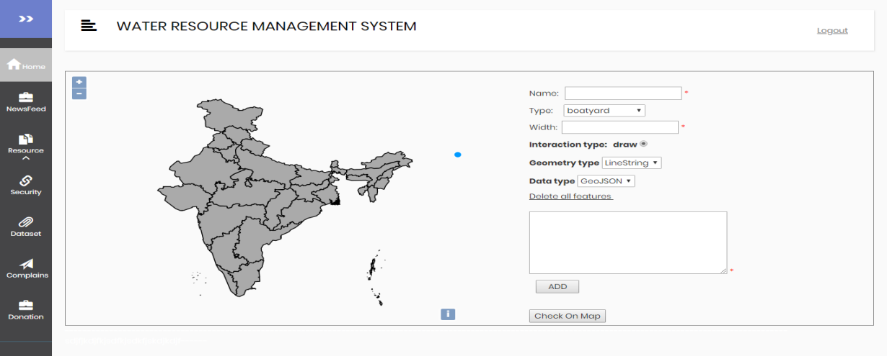

**Figure 6.2.1(11)**

|  |  |  |  |  |
| --- | --- | --- | --- | --- |
| 10 | Security | 1. Enter valid Question | Site should display Success Message | As expected |
|  |  | 2. Without entering any information | Site should display Error Message field is required | Error  Message  Shown |

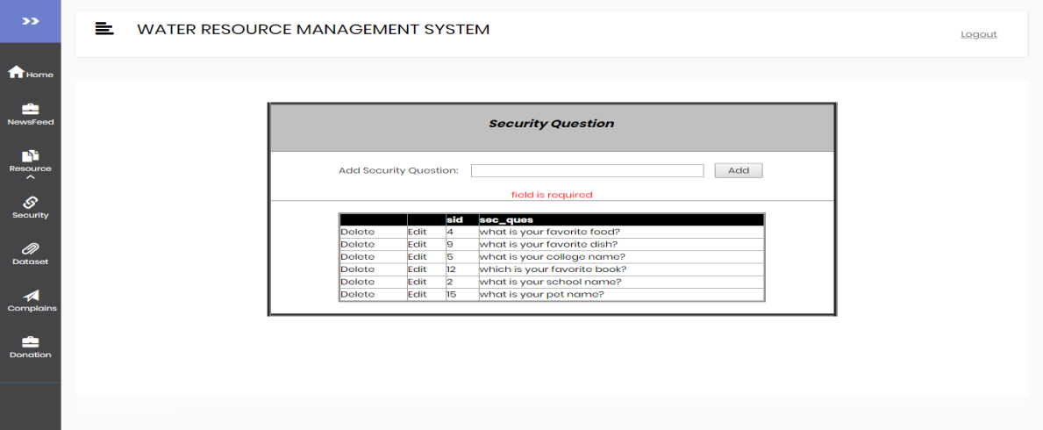

**Figure 6.2.1(12)**

**White-box testing:**

White-box Testing is used as an important primary testing approach. Here code is inspected to see what it does; tests are designed to exercise the code. Code is tested using code scripts, driver etc..,which are employed to directly interface with and drive the code.

The tester can analyze the code and use the knowledge about the surface of a component to derive the test data.

The disadvantages are that exhaustive path testing is infeasible and the logic might not conform to specification. Instrumentation techniques can be used to determine the structural system coverage in white box testing.

Code Coverage

The way to make sure that you have got all the control flow covered is to cover all the paths in the program during the testing (via white-box testing). This implies that both branches are exercised for an „if‟ statement, all branches are exercised for a case statement, the loop is taken once or multiple times as well as ignored for a while statement, and all components of complicated logical expressions are exercised. This is called Path Testing. Additionally, it includes coverage of switch statement cases, exception handlers and interrupts handlers.

Chapter 7

Conclusion and future extension ________________________________________________________________________

**7.1 LIMITATIONS:**

* It can run only on the windows servers. It is not possible with LINUX servers.
* The size of the database increases day-by-day, increasing the load on the data maintenance activity.
* No facility of a Blog/Forum where the general discussions could be maintained.
* Admin cannot upload dataset file more than of size 100 MB.
* System doesn’t provide any information about the type of water available in different water resources.

**7.2 CONCLUSION:**

We conclude that we have successfully implemented all the modules and functionality that were mentioned in the system requirements. All the objectives mentioned earlier in the document have been fulfilled. We learned many new things like SMS facility and the data export facility using the pdf and excel creator code. This project will be used by Government Departments to publish datasets, documents and services for public use and can increase transparency in the functioning of Government.

**7.3 FUTURE EXTENSIONS:**

* This System provides security with verifying phone number which further will be verified by Aadhar-card.
* Further the system may have various other types of government modules like water resource conservation and sanitation, promotional events held by government and different government policies and contest.
* Currently the system takes data from database. In future we can take data from satellite images by using image processing.

Bibliography ________________________________________________________________________

**REFERENCE BOOKS:**

* Beginning asp.net 4.5 in c#matthewmacdonald
* GeoServer- the SLD cookbook
* PostgreSQL 10.3 Documentation Pdf

**INTERNET SOURCES:**

* [**https://data.gov.in**](https://data.gov.in)
* [**http://docs.geoserver.org**](http://docs.geoserver.org)
* [**https://stackoverflow.com**](https://stackoverflow.com)
* [**https://w3layouts.com**](https://w3layouts.com)
* [**https://www.w3schools.com**](https://www.w3schools.com)
* [**https://openlayers.org/en/latest/examples**](https://openlayers.org/en/latest/examples)